Munch & Move Program – News Snippets for Families
Munch & Move news snippets are designed to be included in your regular communications with families such as newsletters, social media posts or an alternate platform such as story park.
These snippets include information about breastfeeding, healthy eating, physical activity or screen time with the aim of supporting healthy lifestyle behaviours at home.
When preparing content to share with families please use the below social tiles and text as a guide. You may also like to include this statement when sharing news snippets:
‘At (service name), we follow the Munch & Move program- a NSW Health initiative that promotes healthy eating, physical activity, and reduced screen time for children aged 0-5 years. This evidence-based program supports your child’s health and wellbeing while in our care.
We’ll be sharing quick tips on topics like nutrition (including breastfeeding), movement, and screen time that you can easily use at home. If you'd like to know more, feel free to chat with us at drop-off or pick-up!’

Healthy Eating
Text | Image
From around 6 months, babies need a variety of solid foods alongside breast milk or formula to help grow healthy and strong.  Good foods for babies from 6 months of age include:  ✔ Iron fortified infant cereal mixed with breastmilk, formula or cooled boiled water.  ✔ Pureed well cooked meat, chicken or fish (no bones).  ✔ Pureed cooked legumes like ‘no added salt’ beans.  Click here to find out more information on good sources of iron: Foods with iron | 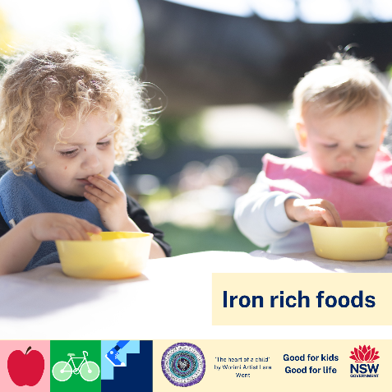
It is very common for children to go through a phase of not wanting to try new foods. Developing a taste for new flavours often takes time, so patience and persistence are key.  Continue offering foods your child may initially refuse, and include a mix of both familiar favourites and new options to encourage exploration.  To learn more: Family Resources | Good for Kids, Good for Life | 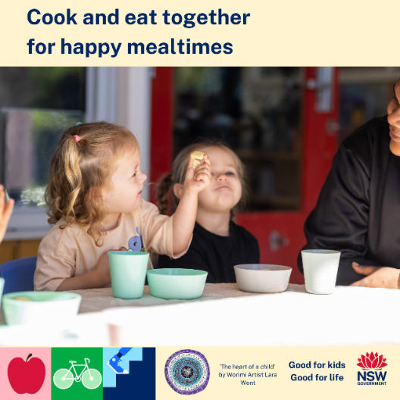
Water is the best drink for anyone who is thirsty.  As the weather warms up don’t forget to:  ✔ Pack a bottle of water with your child’s lunchbox or in their bag.  ✔ Offer water with meals and snacks.  ✔ Show your children that you enjoy drinking water.  Click here for more information: Water handout | 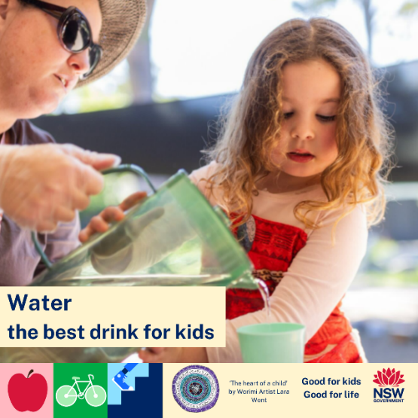
Trying new foods can be scary for children. While it may be frustrating for parents and carers, it is important to stay calm and realise that food refusal can be a normal part of development. In fact, up to 50% of all 0-3 year old children refuse to eat new and different foods at least half the time.  So what can you do? Here are some strategies which may help:  - Let the child serve themselves at mealtimes  - Say “that’s ok if you don’t want to eat it now, maybe you can try it another day”  - Put at least on ‘safe food’ on the plate with the new food  - Talk about the smell, taste, texture and colour of the food  - Allow your child to eat to their appetite and don’t pressure them to try the food or finish the meal  Click here for more information: Encouraging new foods | 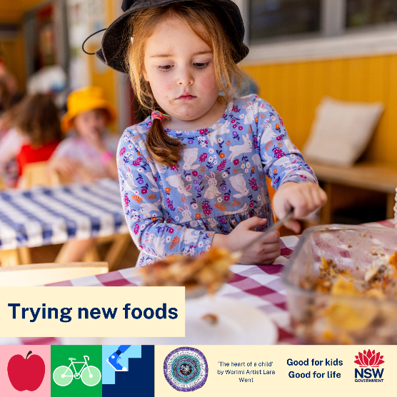
Supporting your child to make their own food book is a great way to encourage discussions around food, be creative and have fun!  You will need:  Paper  Stapler  Scissors  Glue  Magazine with pictures of food  Ideas:  Children love to categorise things. You could encourage categorising by what they like to have for breakfast/lunch/dinner, foods that have different colours, or even what foods to put in the fridge/freezer/cupboard | 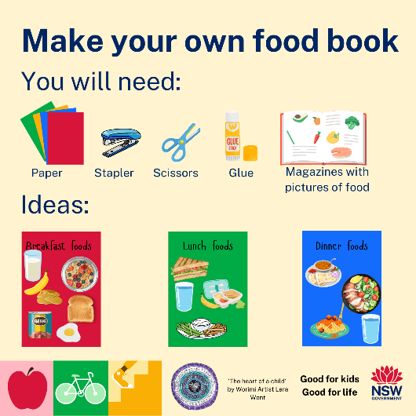

Lunchboxes
Text | Tile
It’s important to pack a balanced lunchbox with veggies, fruits, grains, dairy (e.g. milk, yoghurt or cheese), and protein!  Keep your kids energised and ready to take on the day.  For more healthy lunchbox tips, visit www.healthyliving.nsw.gov.au/healthy-lunchboxes | 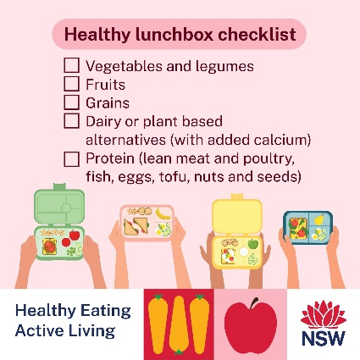
Mornings can be a whirlwind - we get it! Here are some easy lunchbox prep tips to help you get ahead, while still packing nutritious, yummy meals.  ✔ Prep the night before - Chop vegetables into sticks the night before  ✔ Use leftovers – Cook extra serves at dinner the night before  ✔ Portion snacks – Buy popcorn and store in ready to go snack sized portions | 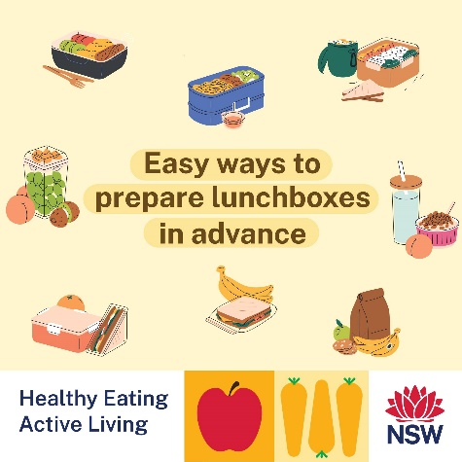  NOTE: 4 social tiles to be shared together (see extra tiles below)
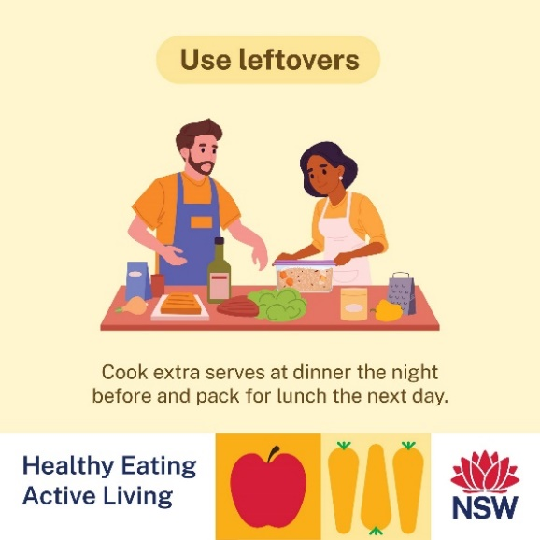
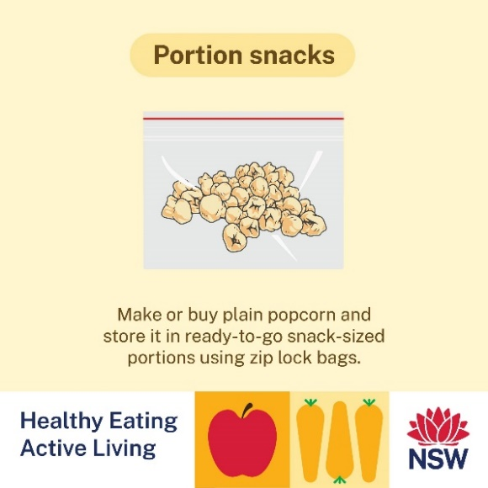
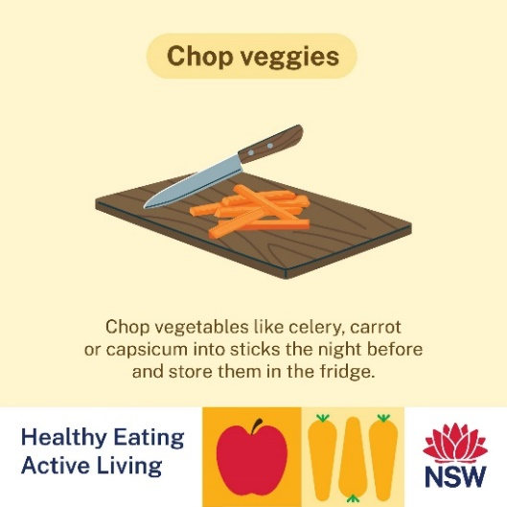
Reminder that no lunchbox is complete without a water bottle!  Keeping hydrated helps kids stay focused, energised and feeling their best throughout the day  Don’t forget to pack a water bottle every day!  For more information on the benefits of water and tips for getting kids to drink more visit http://www.healthyliving.nsw.gov.au/.../tips-for-drinking... | 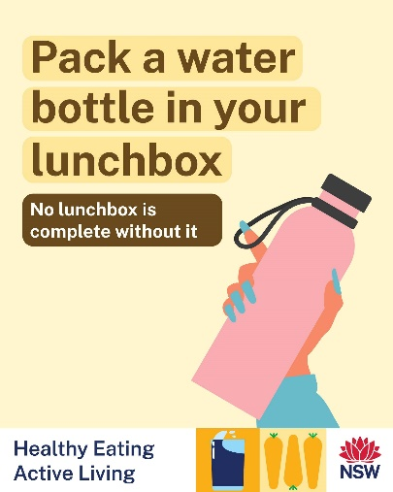
Packing a deadly lunchbox. A healthy lunchbox can help your child concentrate, learn and play while in care!  Aim to include the five food groups:  Vegies  Dairy like cheese or yoghurt  - Wholegrains like grainy or wholemeal bread, wraps, cereal, rice or pasta  Fruit  Protein rich foods like meat, dairy, beans, legumes or eggs  Don’t forget to pack their water bottle!  Thank you to the families and staff from Moree for their support with this resource: Packing a deadly lunchbox | 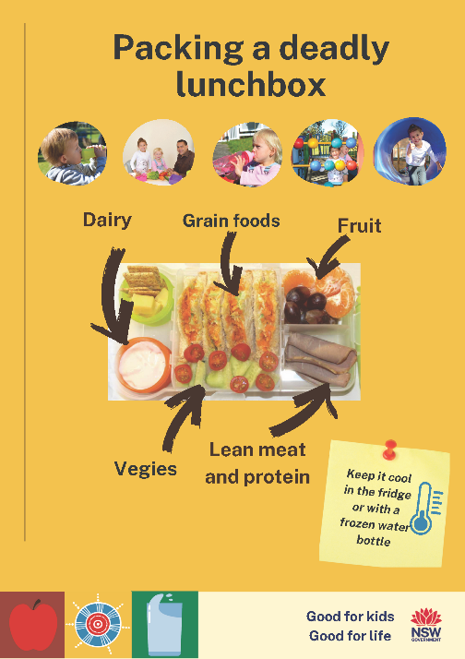

Breastfeeding
Text | Tile
At [service name], we proudly support breastfeeding and understand how important that connection is between mother and child - even during the childcare day.  Whether you're breastfeeding on drop-off, popping in during your break, or expressing milk for later - our team is here to make it as easy and comfortable as possible by providing:  🪑 A private space for feeding or expressing  🍼 Safe storage for expressed milk  💬 Open communication with educators to support your baby’s feeding routine  🤗 A judgement-free, inclusive environment for all feeding choices  If you have questions about breastfeeding at our service or need support, don’t hesitate to reach out! | 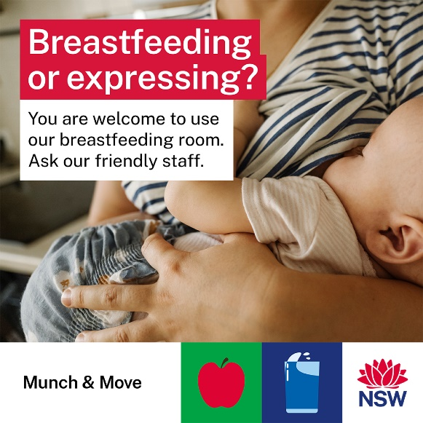

Physical Activity
Text | Image
Play helps develop sturdy brain architecture, the foundations of lifelong health, and the building blocks of resilience.  Follow your child’s lead! Play games they show an interest in and let them determine how long to play.  Check out these games for 6-month-olds: Play handout 6 months  Thanks to the Centre of the Developing Child, Harvard University for creating these handouts | 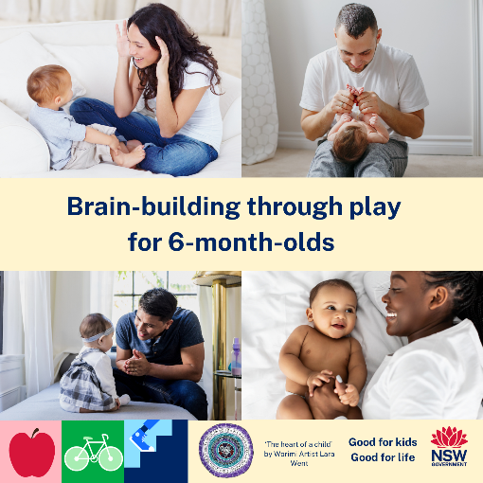
Babies under 12 months need plenty of physical activity throughout the day in a variety of ways to support their development.  For babies who aren’t yet mobile, aim for at least 30 minutes of supervised tummy time across the day with a parent or caregiver. Include activities like reaching, grasping, pushing, and pulling to help build strength and coordination.  Need more ideas? Check out PlayWithMe-0-3yrs.pdf for fun, age-appropriate ways to keep your little one active and engaged. | 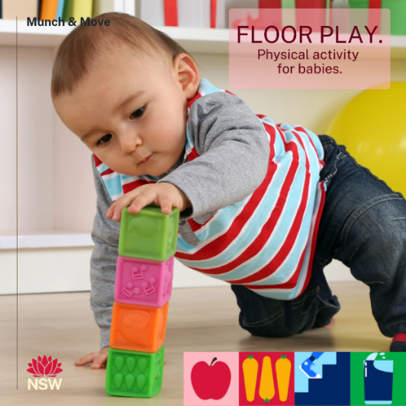
Tummy for play and back for sleep.  Tummy time is important for helping babies build strength and develop healthy motor skills.  When it's time to sleep, always place babies on their backs—this is the safest position for sleep. | 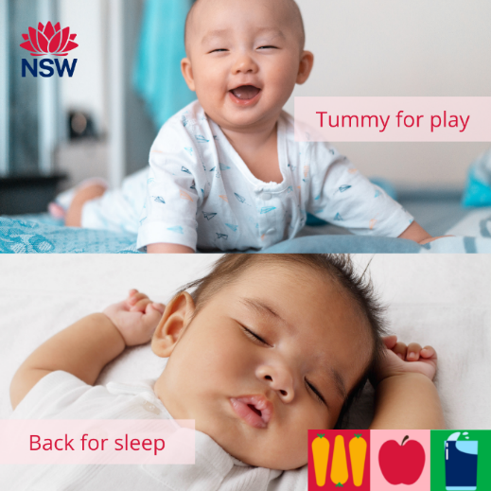
Did you know that the Australian 24-Hour Movement Guidelines recommend children aged 1 - 5 years have at least 3 hours of physical activity spread over the day?  If the weather isn’t great for getting outside, keep everyone active and entertained with these fun indoor activities:  - Create an obstacle course using household items  - Play a game of ‘balloon tennis’ or ‘the floor is lava’  - Try dance videos or yoga for an active screen time break  For more indoor activity ideas: Indoor active play | 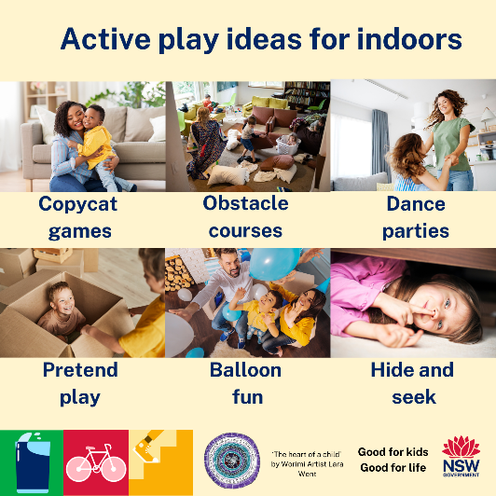
Being active as a family helps build strong bodies, healthy habits, and beautiful memories. Whether it’s a quick dance party in the lounge room or a nature walk around the block, every little bit counts!  Here are some easy ways to get moving at home:  🕺 Have a mini dance party to your child’s favourite songs  🏃‍♀️ Set up an obstacle course in the backyard  🧘 Try some simple kids’ yoga or stretching  🌳 Go on a backyard scavenger hunt  🐸 Play active games like “Simon Says” or “Follow the Leader”  Check out this handout for more ideas: Family Play | 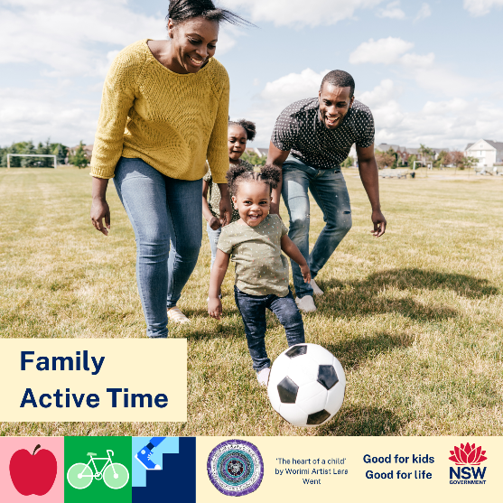
Outdoor play offers many benefits:  Physical development: Encourages kids to be more active, building strength, coordination, and fitness.  ‍‍ Social development - Kids interact more, improving social skills like cooperation, negotiation, and conflict resolution.  Emotional development: Opportunities to assess risks, building independence, resilience, and confidence.  Cognitive development: Enhances learning, communication, focus, problem-solving, and creativity.  Regular time outdoors is essential for your child’s health and wellbeing – it also boosts school readiness! | 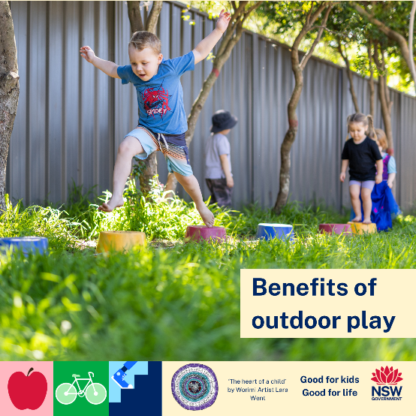
Outdoor play is important for children’s physical and cognitive health and development. But did you know it also helps children build social skills and readiness for school!  Being outdoors provides endless opportunities for children to explore and discover.  Click here to find out more: Outdoor play for children | Raising Children Network | 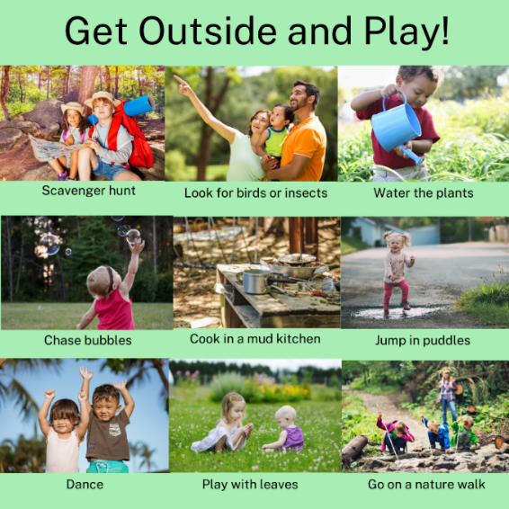
At [service name], we believe a little rain shouldn’t stop the fun!  Over the winter months we’re embracing all the joy that comes with outdoor play— even on wet days!  To help us keep your little ones warm, dry, and happy while exploring the outdoors, we kindly ask families to pack wet weather gear including:  🧥 A waterproof jacket  👢 Gumboots  🧦 Spare clothes and socks  🧤 Warm gloves and beanie for colder days  Outdoor play is not only fun — it also supports your child’s physical, mental, and social growth!  Thanks for your support and helping us keep the adventure going all year round! | 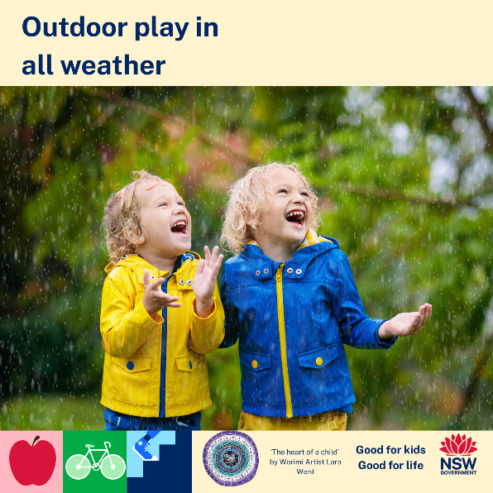
Did you know the early years are the best time for children to develop their Fundamental Movement Skills (FMS)? These are the building blocks for all physical activity - running, jumping, throwing, catching, balancing, and more!  At [service name], we make time every day to practise these skills through fun games, obstacle courses, outdoor play, and movement-based activities.  Here's why these skills are so important:  🌟 They build confidence  💪 They support physical health  🧠 They boost brain development  👫 They facilitate social skills  You can support FMS at home, too. Try these simple activities to get you started: FMS at home  Together, we can help your child build strong foundations for a healthy, active life! | 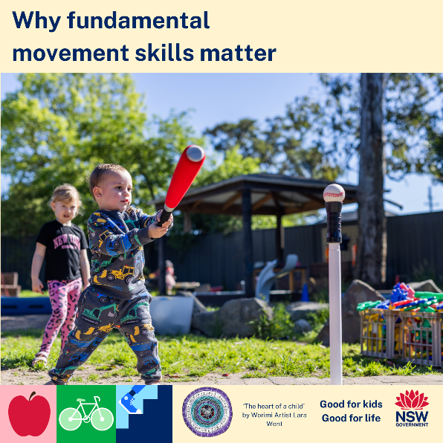
Fundamental movement skills (FMS) are the "building blocks" of movement that children need to learn to play sport. They include activities like running, jumping and catching.Children do not naturally learn these skills therefore it is important they are taught from an early age.  Parents and carers can support and guide children to learn and practise FMS through role modelling and playing games at home such as:  - Hopscotch  - Goal kicking  - Musical statues  For more information and ideas for FMS games, check out our website here. | 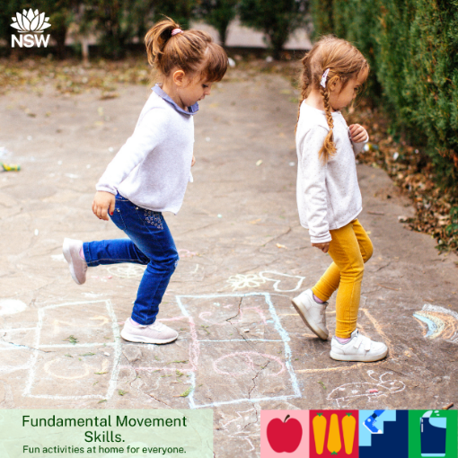
At [service name], you might notice children climbing, balancing on logs, or navigating uneven terrain. This is called risky play — and it’s a good thing!  Risky play doesn't mean unsafe play, it means age-appropriate, supervised challenges that help children learn their own limits and grow in confidence.  Here’s why we embrace risky play in our daily routines:  Builds problem-solving and risk assessment skills  Develops strength, motor fitness, endurance & fundamental movement skills  Supports emotional resilience  Fosters independence  We always provide safe supervision, clear boundaries, and a supportive environment!  Read about how you can facilitate risky play at home: Five ways parents can help their kids take risks – and why it’s good for them | 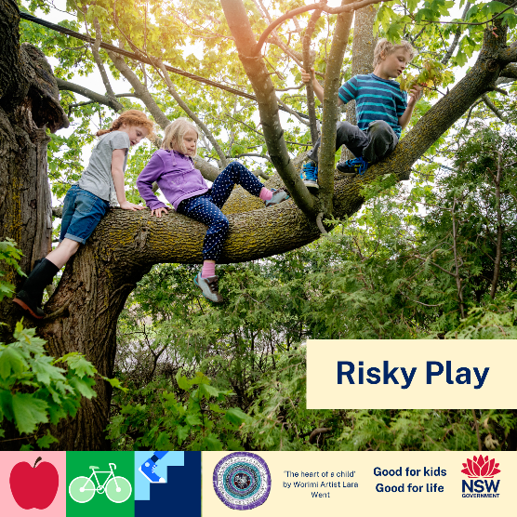

Screentime
Text | Image
For children younger than five years, too much screen time can impact healthy physical development and social skills  What is recommended?  - Under 2 year olds: no screen time  - 2 to 5 year olds: 1 hour per day and less is best!  Tips for managing screen time:  Limit to a set time  Plan screen free activities  Get outside  Role model healthy screen time behaviours  Here are some alternative activities for screentime at home: Managing Screen Time | 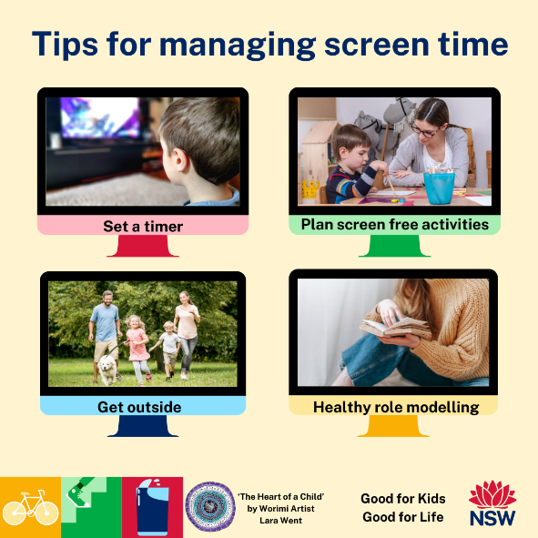
Getting active, limiting screen time and quality sleep is essential for good health at all ages.  Check out this resource with the 24-hour movement guideline for babies, toddlers and preschoolers!  Click on the links to our website for some great ideas to help you reduce screentime and encourage physical activity at home. | 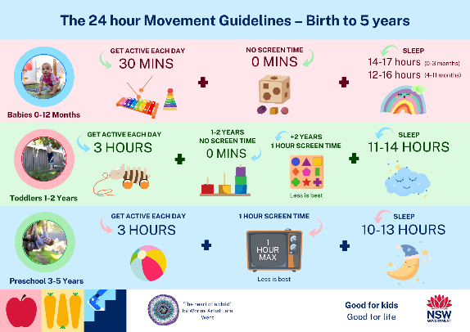
As the weather cools down, families often find themselves spending more time indoors. This can make it more challenging for parents to manage children’s screen time, such as watching TV or using devices.  Setting clear and consistent boundaries around screen use is important for healthy development.  The good news is, there are plenty of fun and active alternatives to keep children engaged indoors.  Here are some great indoor activity ideas:  - Create a simple obstacle course using cushions, chairs, and other furniture  - Involve children in cooking or baking activities  - Use dance or movement videos to encourage active screen time | 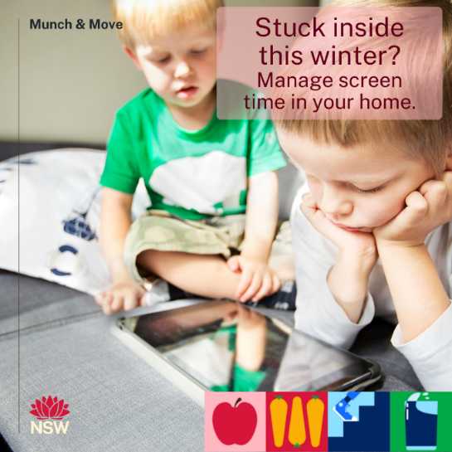

Other health topics
Text | Image
Did you know that the NSW Public Dental Services provide free dental care for all children under the age of 18 with a Medicare card?  Top tips for healthy smiles under 5:  Brush your teeth morning and night  Eat more fruit and veg  Choose water as a drink  Have regular dental check-ups  For more info: Healthy Smiles under 5 | 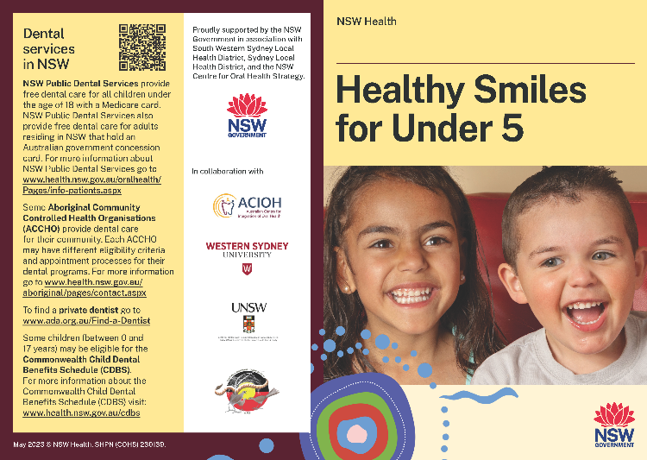
Raising children is an important job, and looking after your own health helps you do the job well!  Looking after yourself physically, mentally and emotionally gives you the energy you need to help your child grow and develop  The 'Get Healthy Service' provides support to make healthy lifestyle changes and stay motivated to reach your goals. Sign up online or call to access free university qualified health coaching.  - Call 1300 806 258  - Monday to Friday 8am to 8pm  - Saturday 9am to 5pm  Learn more gethealthynsw.com.au | 