Tiny Bites Snippet: The journey of starting solids & texture progression

Choose the snippet option you would like to share with families at your service.
You may like to share the snippet in multiple formats!
Option 1
Formatted Snippet / PDF (this one isn’t modifiable) – click here.

Option 2
Word document (with modifiable text) – click here.

Option 3
Create Your Own (with modifiable text) - click here.
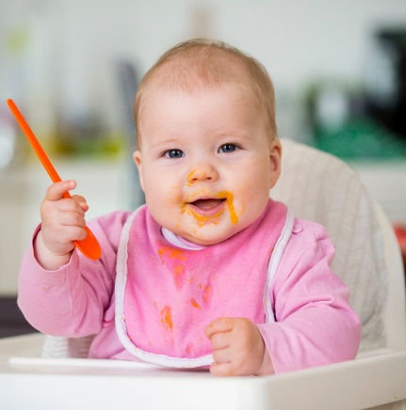

Contact your Tiny Bites Support Officer if you have any questions or require support in tailoring your snippets.

Option 1 – Formatted Snippet / PDF:

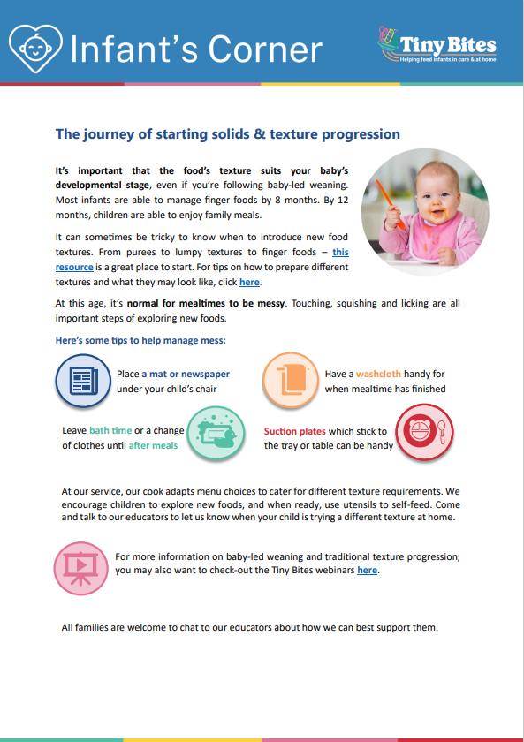 | The PDF version of the snippet can be found here:  https://www.goodforkids.nsw.gov.au/media/3042/snippet-3-starting-solids-texture-progression-menu-services-pdf.pdf  Examples of how this version could be shared with families:  - Attach to emails  - Add to existing newsletters  - Printed copies for handouts, parent pockets or to display in the service  You can share this version with families as is without making any edits. This version contains additional visual elements compared to other versions but doesn’t contain the modifiable text which appears in the other formats.  Please note, because this version is in PDF format, the content is unable to be edited. If you would like to use this version but require edits to be made, please contact your Tiny Bites Support Officer at: hnelhd-pophealthgfkresearch@health.nsw.gov.au

Option 2 – Editable word document:

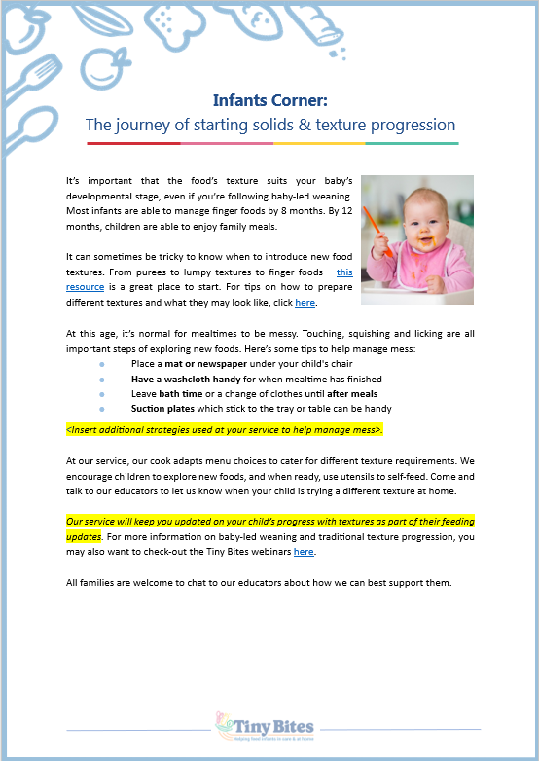 | The editable word version of the snippet can be found here:  https://www.goodforkids.nsw.gov.au/media/3039/snippet-3-starting-solids-texture-progression-menu-services-word-doc.docx  Examples of how this version could be shared with families:  - Copy across to the body of emails or include as attachments  - Add to existing newsletters  - Printed copies for handouts, parent pockets or to display in the service  Feel free to edit the content in the document to align with your service’s preferences  and practices. When editing the word document, we recommend the snippet still includes:  - Why the practice is important  - How families may implement the practice  - How the service implements the practice  - Links to resources  Note, there is optional / modifiable content highlighted in yellow in the document. Please either:  - make any necessary edits to this content to suit your service’s needs and then remove the highlight  - remove the content highlighted in yellow if it’s not relevant  You may also like to add your own photos and logos to this version of the snippet.

Option 3 – Create Your Own
If you’re creating your own, we recommend the snippet still includes:
- Why the practice is important
- How families may implement the practice
- How the service implements the practice
- Links to resources

Heading | Content | Image/Picture | Logo
 | Feel free to edit the content below to suit your service’s practices and preferences. You may like to add in your strategies used at the service to support infants on their journey to starting solids, and/or strategies to manage mess at mealtimes (see optional content highlighted in yellow below). For the highlighted content, please either:  - make any necessary edits to this content to suit your service’s needs and then remove the highlight  - remove the content highlighted in yellow if it’s not relevant | Feel free to swap out for your own photo. | You may also like to add your own logo as well.
Infant’s Corner: The journey of starting solids & texture progression | It’s important that the food’s texture suits your baby’s developmental stage, even if you’re following baby-led weaning. Most infants are able to manage finger foods by 8 months. By 12 months, children are able to enjoy family meals.  It can sometimes be tricky to know when to introduce new food textures. From purees to lumpy textures to finger foods – this resource is a great place to start. For tips on how to prepare different textures and what they may look like, click here.  At this age, it’s normal for mealtimes to be messy. Touching, squishing and licking are all important steps of exploring new foods. Here’s some tips to help manage mess:  - Place a mat or newspaper under your child's chair  - Have a washcloth handy for when mealtime has finished  - Leave bath time or a change of clothes until after meals  - Suction plates which stick to the tray or table can be handy  <Insert additional strategies used at your service to help manage mess>.  At our service, our cook adapts menu choices to cater for different texture requirements. We encourage children to explore new foods, and when ready, use utensils to self-feed. Come and talk to our educators to let us know when your child is trying a different texture at home.  Our service will keep you updated on your child’s progress with textures as part of their feeding updates. For more information on baby-led weaning and traditional texture progression, you may also want to check-out the Tiny Bites webinars here.  All families are welcome to chat to our educators about how we can best support them. |  | 

