**Infants Corner:**

The journey of starting solids & texture progression

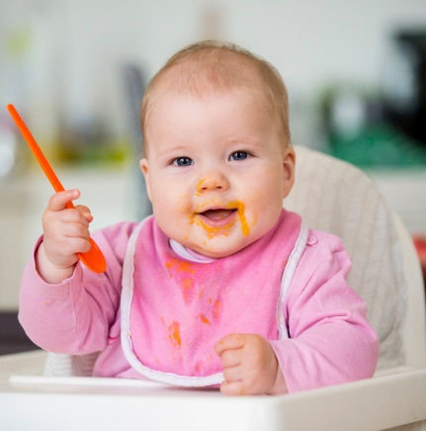It’s important that the food’s texture suits your baby’s developmental stage, even if you’re following baby-led weaning. Most infants are able to manage finger foods by 8 months. By 12 months, children are able to enjoy family meals.

It can sometimes be tricky to know when to introduce new food textures. From purees to lumpy textures to finger foods – [this resource](https://healthykids.nsw.gov.au/downloads/file/teacherschildcare/TransitioningTextures-Infants.pdf) is a great place to start. For tips on how to prepare different textures and what they may look like, click [here](https://health-promotion.nnswlhd.health.nsw.gov.au/feeding-babies/changing-the-texture-of-foods/).

At this age, it’s normal for mealtimes to be messy. Touching, squishing and licking are all important steps of exploring new foods. Here’s some tips to help manage mess:

* Place a **mat or newspaper** under your child's chair
* **Have a washcloth handy** for when mealtime has finished
* Leave **bath time** or a change of clothes until **after meals**
* **Suction plates** which stick to the tray or table can be handy

*<Insert additional strategies used at your service to help manage mess>.*

At our service, our cook adapts menu choices to cater for different texture requirements. We encourage children to explore new foods, and when ready, use utensils to self-feed. Come and talk to our educators to let us know when your child is trying a different texture at home.

*Our service will keep you updated on your child’s progress with textures as part of their feeding updates.* For more information on baby-led weaning and traditional texture progression, you may also want to check-out the Tiny Bites webinars [here](https://tinybites.info/webinar).

All families are welcome to chat to our educators about how we can best support them.