Tiny Bites Snippet: Creating a Positive Mealtime Environment

Choose the snippet option you would like to share with families at your service.
You may like to share the snippet in multiple formats!
Option 1
Formatted Snippet / PDF (this one isn’t modifiable) – click here.

Option 2
Word document (with modifiable text) – click here.

Option 3
Create Your Own (with modifiable text) click here.
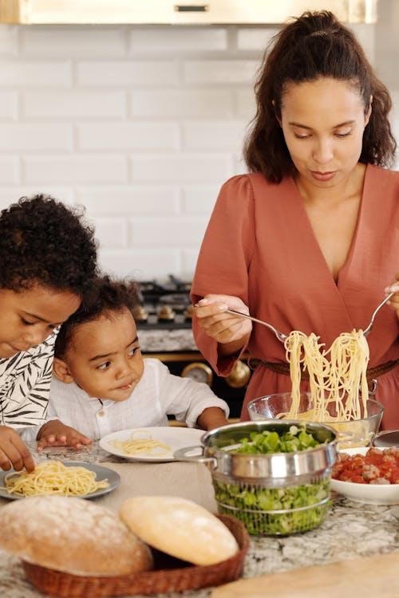

Contact your Tiny Bites Support Officer if you have any questions or require support in tailoring your snippets.

Option 1 – Formatted Snippet / PDF:

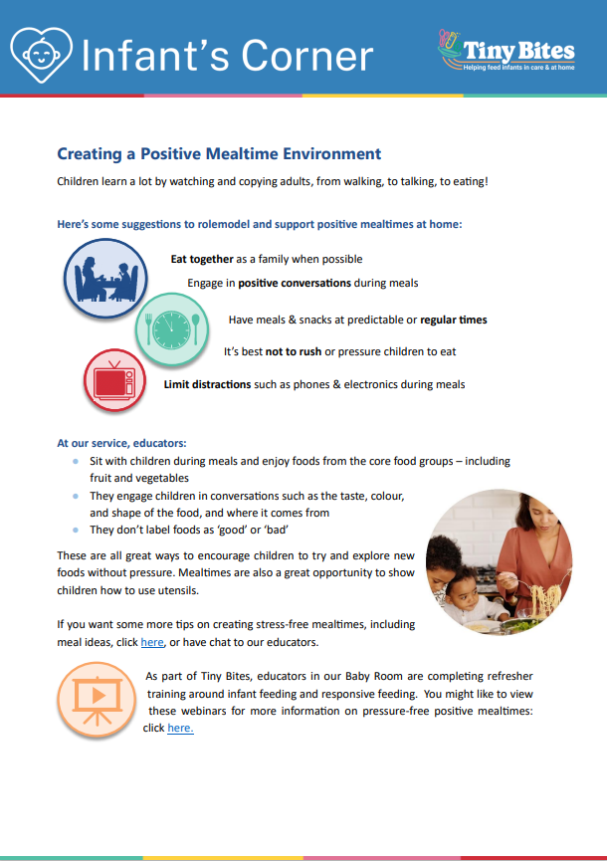 | The PDF version of the snippet can be found here:  https://www.goodforkids.nsw.gov.au/media/3035/snippet-6-creating-a-positive-mealtime-environment_pdf.pdf  Examples of how this version could be shared with families:  - Attach to emails  - Add to existing newsletters  - Printed copies for handouts, parent pockets or to display in the service  You can share this version with families as is without making any edits. This version contains additional visual elements compared to other versions but doesn’t contain the modifiable text which appears in the other formats.  Please note, because this version is in PDF format, the content is unable to be edited. If you would like to use this version but require edits to be made, please contact your Tiny Bites Support Officer at: hnelhd-pophealthgfkresearch@health.nsw.gov.au

Option 2 – Editable word document:

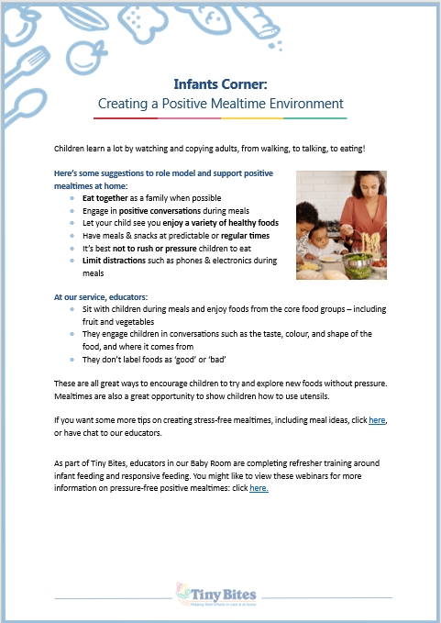 | The editable word version of the snippet can be found here:  https://www.goodforkids.nsw.gov.au/media/3036/snippet-6-creating-a-positive-mealtime-environment-word-doc.docx  Examples of how this version could be shared with families:  - Copy across to the body of emails or include as attachments  - Add to existing newsletters  - Printed copies for handouts, parent pockets or to display in the service  Feel free to edit the content in the document to align with your service’s preferences  and practices. When editing the word document, we recommend the snippet still includes:  - Why the practice is important  - How families may implement the practice  - How the service implements the practice  - Links to resources  You may also like to add your own photos and logos to this version of the snippet.

Option 3 – Create Your Own
If you’re creating your own, we recommend the snippet still includes:
- Why the practice is important
- How families may implement the practice
- How the service implements the practice
- Links to resources

Heading | Content | Image/Picture | Logo
 | Feel free to edit the content below to suit your service’s practices and preferences. You may like to add in your strategies used at the service to create positive mealtimes. | Feel free to swap out for your own photo. | You may also like to add your own logo as well.
Infants Corner: Creating a Positive Mealtime Environment | Children learn a lot by watching and copying adults, from walking, to talking, to eating!  Here’s some suggestions to rolemodel and support positive mealtimes at home:  - Eat together as a family when possible  - Engage in positive conversations during meals  - Let your child see you enjoy a variety of healthy foods  - Have meals & snacks at predictable or regular times  - It’s best not to rush or pressure children to eat  - Limit distractions such as phones & electronics during meals  At our service, educators:  - Sit with children during meals and enjoy foods from the core food groups – including fruit and vegetables  - They engage children in conversations such as the taste, colour, and shape of the food, and where it comes from  - They don’t label foods as ‘good’ or ‘bad’  These are all great ways to encourage children to try and explore new foods without pressure. Mealtimes are also a great opportunity to show children how to use utensils.  If you want some more tips on creating stress-free mealtimes, including meal ideas, click here, or have chat to our educators.  As part of Tiny Bites, educators in our Baby Room are completing refresher training around infant feeding and responsive feeding. You might like to view these webinars for more information on pressure-free positive mealtimes: click here. |  | 

