**Infants Corner:**

Creating a Positive Mealtime Environment

Children learn a lot by watching and copying adults, from walking, to talking, to eating!

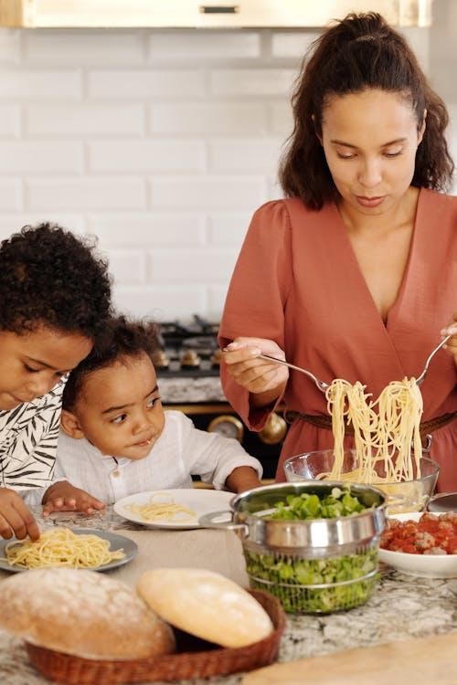**Here’s some suggestions to role model and support positive mealtimes at home:**

* **Eat together** as a family when possible
* Engage in **positive conversations** during meals
* Let your child see you **enjoy a variety of healthy foods**
* Have meals & snacks at predictable or **regular times**
* It’s best **not to rush or pressure** children to eat
* **Limit distractions** such as phones & electronics during meals

**At our service, educators:**

* Sit with children during meals and enjoy foods from the core food groups – including fruit and vegetables
* They engage children in conversations such as the taste, colour, and shape of the food, and where it comes from
* They don’t label foods as ‘good’ or ‘bad’

These are all great ways to encourage children to try and explore new foods without pressure. Mealtimes are also a great opportunity to show children how to use utensils.

If you want some more tips on creating stress-free mealtimes, including meal ideas, click [here](https://www.goodforkids.nsw.gov.au/media/2268/family-mealtimes.pdf), or have chat to our educators.

As part of Tiny Bites, educators in our Baby Room are completing refresher training around infant feeding and responsive feeding. You might like to view these webinars for more information on pressure-free positive mealtimes: click [here.](https://tinybites.info/webinar)