Tiny Bites Snippet: How we put in place the Infant Feeding Guidelines

Choose the snippet option you would like to share with families at your service.
You may like to share the snippet in multiple formats!
Option 1
Formatted Snippet / PDF (this one isn’t modifiable) – click here.

Option 2
Word document (with modifiable text) – click here.

Option 3
Create Your Own (with modifiable text) - click here.


Contact your Tiny Bites Support Officer if you have any questions or require support in tailoring your snippets.

Option 1 – Formatted Snippet / PDF:

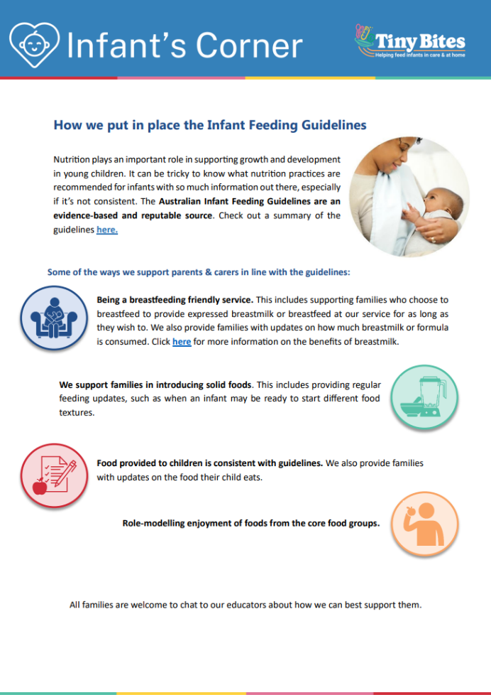 | The PDF version of the snippet can be found here:  https://www.goodforkids.nsw.gov.au/media/3032/snippet-2-infant-feeding-guidelines-pdf.pdf  Examples of how this version could be shared with families:  - Attach to emails  - Add to existing newsletters  - Printed copies for handouts, parent pockets or to display in the service  You can share this version with families as is without making any edits. This version contains additional visual elements compared to other versions but doesn’t contain the modifiable text which appears in the other formats.  Please note, because this version is in PDF format, the content is unable to be edited. If you would like to use this version but require edits to be made, please contact your Tiny Bites Support Officer at: hnelhd-pophealthgfkresearch@health.nsw.gov.au

Option 2 – Editable word document:

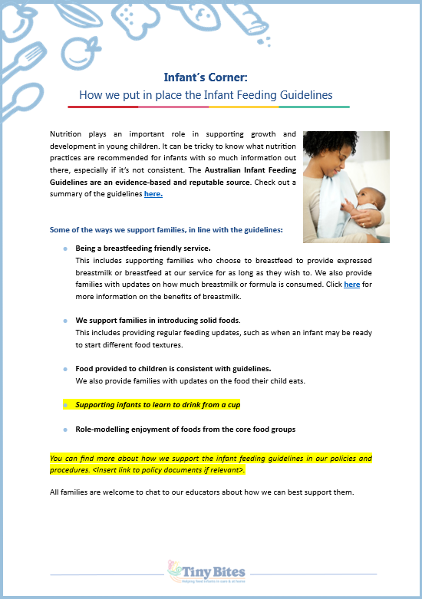 | The editable word version of the snippet can be found here:  https://www.goodforkids.nsw.gov.au/media/3031/snippet-2-infant-feeding-guidelines-word-doc.docx  Examples of how this version could be shared with families:  - Copy across to the body of emails or include as attachments  - Add to existing newsletters  - Printed copies for handouts, parent pockets or to display in the service  Feel free to edit the content in the document to align with your service’s preferences  and practices. When editing the word document, we recommend the snippet still includes:  - Why the practice is important  - How families may implement the practice  - How the service implements the practice  - Links to resources  Note, there is optional / modifiable content highlighted in yellow in the document. Please either:  - make any necessary edits to this content to suit your service’s needs and then remove the highlight  - remove the content highlighted in yellow if it’s not relevant  You may also like to add your own photos and logos to this version of the snippet.

Option 3 – Create Your Own
If you’re creating your own, we recommend the snippet still includes:
- Why the practice is important
- How families may implement the practice
- How the service implements the practice
- Links to resources

Heading | Content | Image/Picture | Logo
 | Feel free to edit the content below to suit your service’s practices and preferences. You may like to add in your strategies used at the service to support families in line with the guidelines (see optional content highlighted in yellow below). For the highlighted content, please either:  - make any necessary edits to this content to suit your service’s needs and then remove the highlight  - remove the content highlighted in yellow if it’s not relevant | Feel free to swap out for your own photo. | You may also like to add your own logo as well.
Infant’s Corner: How we put in place the Infant Feeding Guidelines | Nutrition plays an important role in supporting growth and development in young children. It can be tricky to know what nutrition practices are recommended for infants with so much information out there, especially if it’s not consistent. The Australian Infant Feeding Guidelines are an evidence-based and reputable source. Check out a summary of the guidelines here.  Some of the ways we support families, in line with the guidelines:  - Being a breastfeeding friendly service. This includes supporting families who choose to breastfeed to provide expressed breastmilk or breastfeed at our service for as long as they wish to. We also provide families with updates on how much breastmilk or formula is consumed. Click here for more information on the benefits of breastmilk.  - We support families in introducing solid foods. This includes providing regular feeding updates, such as when an infant may be ready to start different food textures.  - Food provided to children is consistent with guidelines. We also provide families with updates on the food their child eats.  - Supporting infants to learn to drink from a cup  - Role-modelling enjoyment of foods from the core food groups  You can find more about how we support the infant feeding guidelines in our policies and procedures. <Insert link to policy documents if relevant>.  All families are welcome to chat to our educators about how we can best support them. |  | 

