Tiny Bites Snippet: Recommended foods for under 2’s

Choose the snippet option you would like to share with families at your service.
You may like to share the snippet in multiple formats!
Option 1
Formatted Snippet / PDF (this one isn’t modifiable) – click here.

Option 2
Word document (with modifiable text) – click here.

Option 3
Create Your Own (with modifiable text) - click here.
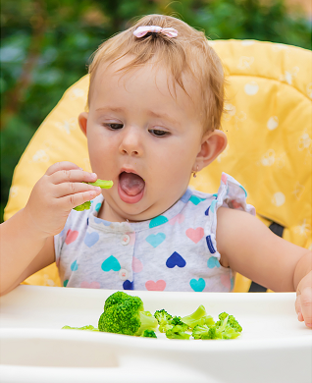

Contact your Tiny Bites Support Officer if you have any questions or require support in tailoring your snippets.

Option 1 – Formatted Snippet / PDF:

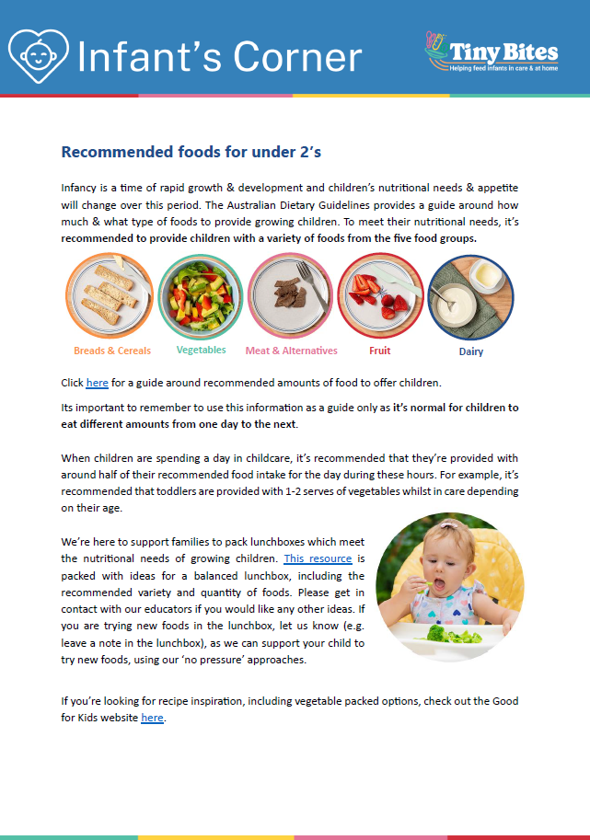 | The PDF version of the snippet can be found here:  https://www.goodforkids.nsw.gov.au/media/3023/snippet-7-recommended-foods-for-under-2s-lunchbox-services-pdf.pdf  Examples of how this version could be shared with families:  - Attach to emails  - Add to existing newsletters  - Printed copies for handouts, parent pockets or to display in the service  You can share this version with families as is without making any edits. This version contains additional visual elements compared to other versions but doesn’t contain the modifiable text which appears in the other formats.  Please note, because this version is in PDF format, the content is unable to be edited. If you would like to use this version but require edits to be made, please contact your Tiny Bites Support Officer at: hnelhd-pophealthgfkresearch@health.nsw.gov.au

Option 2 – Editable word document:

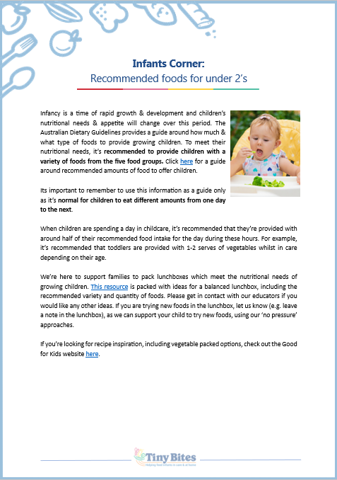 | The editable word version of the snippet can be found here:  https://www.goodforkids.nsw.gov.au/media/3024/snippet-7-recommended-foods-for-under-2s-lunchbox-services-word-doc.docx  Examples of how this version could be shared with families:  - Copy across to the body of emails or include as attachments  - Add to existing newsletters  - Printed copies for handouts, parent pockets or to display in the service  Feel free to edit the content in the document to align with your service’s preferences  and practices. When editing the word document, we recommend the snippet still includes:  - Why the practice is important  - How families may implement the practice  - How the service implements the practice  - Links to resources  You may also like to add your own photos and logos to this version of the snippet.

Option 3 – Create Your Own
If you’re creating your own, we recommend the snippet still includes:
- Why the practice is important
- How families may implement the practice
- How the service implements the practice
- Links to resources

Heading | Content | Image/Picture | Logo
 | Feel free to edit the content below to suit your service’s practices and preferences. You may like to add in your strategies used at the service to support families to provide foods consistent with the guidelines. | Feel free to swap out for your own photo. | You may also like to add your own logo as well.
Infant’s Corner: Recommended foods for under 2’s | Infancy is a time of rapid growth & development and children’s nutritional needs & appetite will change over this period. The Australian Dietary Guidelines provides a guide around how much & what type of foods to provide growing children. To meet their nutritional needs, it’s recommended to provide children with a variety of foods from the five food groups. Click here for a guide around recommended amounts of food to offer children.  Its important to remember to use this information as a guide only as it’s normal for children to eat different amounts from one day to the next.  When children are spending a day in childcare, it’s recommended that they’re provided with around half of their recommended food intake for the day during these hours. For example, it’s recommended that toddlers are provided with 1-2 serves of vegetables whilst in care depending on their age.  We’re here to support families to pack lunchboxes which meet the nutritional needs of growing children. This resource is packed with ideas for a balanced lunchbox, including the recommended variety and quantity of foods. Please get in contact with our educators if you would like any other ideas. If you are trying new foods in the lunchbox, let us know (e.g. leave a note in the lunchbox), as we can support your child to try new foods, using our ‘no pressure’ approaches.  If you’re looking for recipe inspiration, including vegetable packed options, check out the Good for Kids website here. |  | 

