**Infants Corner:**

Recommended foods for under 2’s

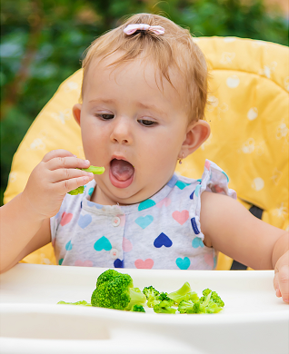Infancy is a time of rapid growth & development and children’s nutritional needs & appetite will change over this period. The Australian Dietary Guidelines provides a guide around how much & what type of foods to provide growing children. To meet their nutritional needs, it’s **recommended to provide children with a variety of foods from the five food groups.** Click [here](https://www.goodforkids.nsw.gov.au/media/2977/serve-size-guide-7-months-to-5-years.pdf) for a guide around recommended amounts of food to offer children.

Its important to remember to use this information as a guide only as it’s **normal for children to eat different amounts from one day to the next**.

When children are spending a day in childcare, it’s recommended that they’re provided with around half of their recommended food intake for the day during these hours. For example, it’s recommended that toddlers are provided with 1-2 serves of vegetables whilst in care depending on their age.

We’re here to support families to pack lunchboxes which meet the nutritional needs of growing children. [This resource](https://www.goodforkids.nsw.gov.au/media/2984/lunchbox-ideas-for-0-2-years.pdf) is packed with ideas for a balanced lunchbox, including the recommended variety and quantity of foods. Please get in contact with our educators if you would like any other ideas. If you are trying new foods in the lunchbox, let us know (e.g. leave a note in the lunchbox), as we can support your child to try new foods, using our ‘no pressure’ approaches.

If you’re looking for recipe inspiration, including vegetable packed options, check out the Good for Kids website [here](https://goodforkids.nsw.gov.au/early-childhood-services/resources/parent-carer-resources/recipes/).