Tiny Bites Snippet: How to Comfort & Reward Without Food

Choose the snippet option you would like to share with families at your service.
You may like to share the snippet in multiple formats!
Option 1
Formatted Snippet / PDF (this one isn’t modifiable) – click here.

Option 2
Word document (with modifiable text) – click here.

Option 3
Create Your Own (with modifiable text) - click here.



Contact your Tiny Bites Support Officer if you have any questions or require support in tailoring your snippets.

Option 1 – Formatted Snippet / PDF:

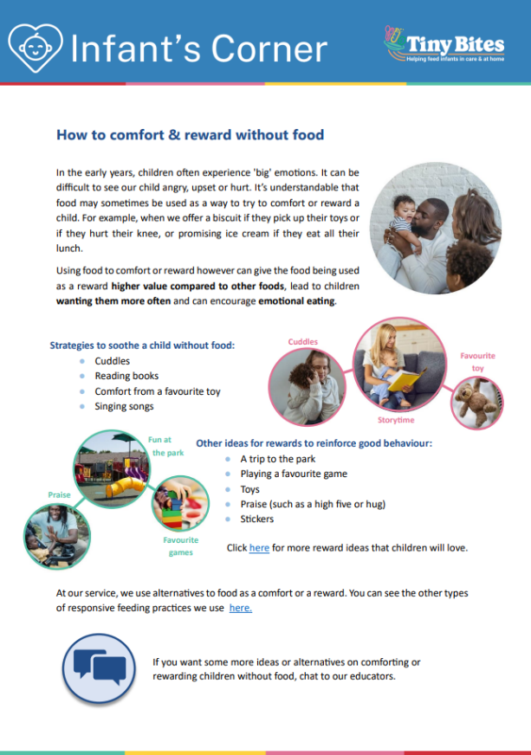 | The PDF version of the snippet can be found here:  https://www.goodforkids.nsw.gov.au/media/3019/snippet-9-how-to-comfort-and-reward-without-food_pdf.pdf  Examples of how this version could be shared with families:  - Attach to emails  - Add to existing newsletters  - Printed copies for handouts, parent pockets or to display in the service  You can share this version with families as is without making any edits. This version contains additional visual elements compared to other versions but doesn’t contain the modifiable text which appears in the other formats.  Please note, because this version is in PDF format, the content is unable to be edited. If you would like to use this version but require edits to be made, please contact your Tiny Bites Support Officer at: hnelhd-pophealthgfkresearch@health.nsw.gov.au

Option 2 – Editable word document:

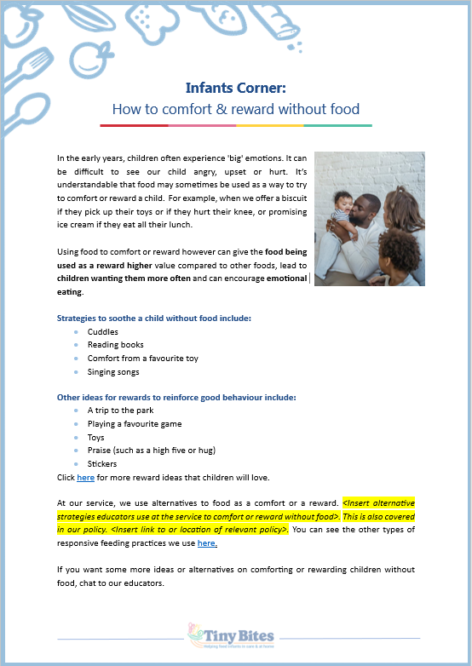 | The editable word version of the snippet can be found here:  https://www.goodforkids.nsw.gov.au/media/3020/snippet-9-how-to-comfort-and-reward-without-food_word-doc.docx  Examples of how this version could be shared with families:  - Copy across to the body of emails or include as attachments  - Add to existing newsletters  - Printed copies for handouts, parent pockets or to display in the service  Feel free to edit the content in the document to align with your service’s preferences  and practices. When editing the word document, we recommend the snippet still includes:  - Why the practice is important  - How families may implement the practice  - How the service implements the practice  - Links to resources  Note, there is optional / modifiable content highlighted in yellow in the document. Please either:  - make any necessary edits to this content to suit your service’s needs and then remove the highlight  - remove the content highlighted in yellow if it’s not relevant  You may also like to add your own photos and logos to this version of the snippet.

Option 3 – Create Your Own
If you’re creating your own, we recommend the snippet still includes:
- Why the practice is important
- How families may implement the practice
- How the service implements the practice
- Links to resources

Heading | Content | Image/Picture | Logo
 | Feel free to edit the content below to suit your service’s practices and preferences You may like to add in your strategies used at the service to comfort or reward (see optional content highlighted in yellow below). For the highlighted content, please either:  - make any necessary edits to this content to suit your service’s needs and then remove the highlight  - remove the content highlighted in yellow if it’s not relevant | Feel free to swap out for your own photo. | You may also like to add your own logo as well.
Infant’s Corner: How to comfort & reward without food | In the early years, children often experience 'big' emotions. It can be difficult to see our child angry, upset or hurt. It’s understandable that food may sometimes be used as a way to try to comfort or reward a child. For example, when we offer a biscuit if they pick up their toys or if they hurt their knee, or promising ice cream if they eat all their lunch.  Using food to comfort or reward however can give the food being used as a reward higher value compared to other foods, lead to children wanting them more often, and can encourage emotional eating.  Strategies to soothe a child without food include:  - Cuddles  - Reading books  - Comfort from a favourite toy  - Singing songs  Other ideas for rewards to reinforce good behaviour include:  - A trip to the park  - Playing a favourite game  - Toys  - Praise (such as a high five or hug)  - Stickers  Click here for more reward ideas that children will love.  At our service, we use alternatives to food as a comfort or a reward. <Insert alternative strategies educators use at the service to comfort or reward without food>. This is also covered in our policy. <Insert link to or location of relevant policy>. You can see the other types of responsive feeding practices we use here.  If you want some more ideas or alternatives on comforting or rewarding children without food, chat to our educators. |  | 

