**Infants Corner:**

How to comfort & reward without food

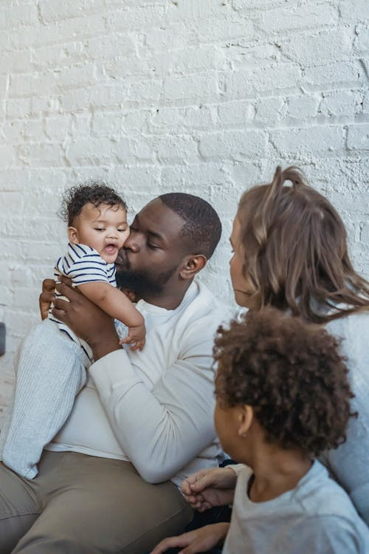In the early years, children often experience 'big' emotions. It can be difficult to see our child angry, upset or hurt. It’s understandable that food may sometimes be used as a way to try to comfort or reward a child. For example, when we offer a biscuit if they pick up their toys or if they hurt their knee, or promising ice cream if they eat all their lunch.

Using food to comfort or reward however can give the **food being used as a reward higher** value compared to other foods, lead to **children wanting them more often**, and can encourage **emotional eating**.

**Strategies to soothe a child without food include:**

* Cuddles
* Reading books
* Comfort from a favourite toy
* Singing songs

**Other ideas for rewards to reinforce good behaviour include:**

* A trip to the park
* Playing a favourite game
* Toys
* Praise (such as a high five or hug)
* Stickers

Click [here](https://goodforkids.nsw.gov.au/media/2416/non-food-rewards.pdf) for more reward ideas that children will love.

At our service, we use alternatives to food as a comfort or a reward. *<Insert alternative strategies educators use at the service to comfort or reward without food>. This is also covered in our policy. <Insert link to or location of relevant policy>.* You can see the other types of responsive feeding practices we use [here.](https://www.goodforkids.nsw.gov.au/media/3018/responsive-feeding-poster.pdf)

If you want some more ideas or alternatives on comforting or rewarding children without food, chat to our educators.