Tiny Bites Snippet: Foods best to avoid for under 2’s

Choose the snippet option you would like to share with families at your service.
You may like to share the snippet in multiple formats!
Option 1
Formatted Snippet / PDF (this one isn’t modifiable) – click here.

Option 2
Word document (with modifiable text) – click here.

Option 3
Create Your Own (with modifiable text) - click here.
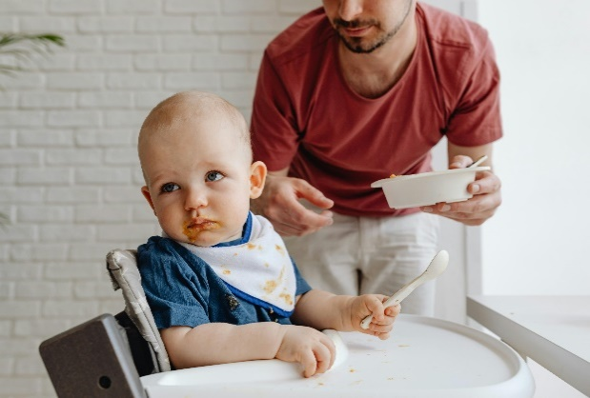

Contact your Tiny Bites Support Officer if you have any questions or require support in tailoring your snippets.

Option 1 – Formatted Snippet / PDF:

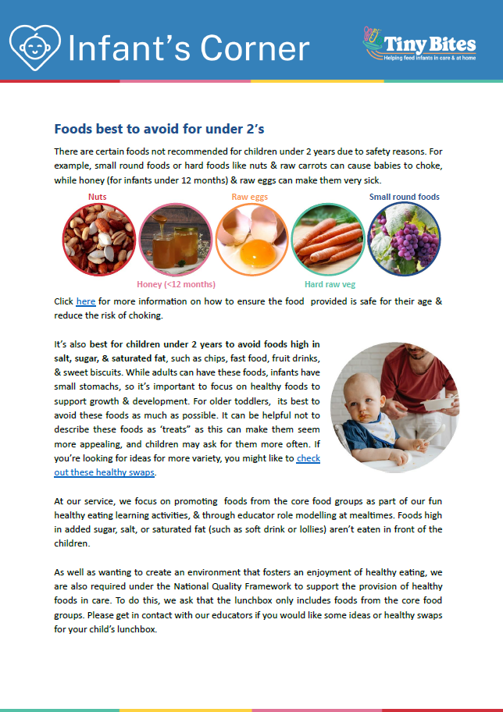 | The PDF version of the snippet can be found here:  https://www.goodforkids.nsw.gov.au/media/3014/snippet-8-foods-best-to-avoid-for-under-2s-lunchbox-services-pdf.pdf  Examples of how this version could be shared with families:  - Attach to emails  - Add to existing newsletters  - Printed copies for handouts, parent pockets or to display in the service  You can share this version with families as is without making any edits. This version contains additional visual elements compared to other versions but doesn’t contain the modifiable text which appears in the other formats.  Please note, because this version is in PDF format, the content is unable to be edited. If you would like to use this version but require edits to be made, please contact your Tiny Bites Support Officer at: hnelhd-pophealthgfkresearch@health.nsw.gov.au

Option 2 – Editable word document:

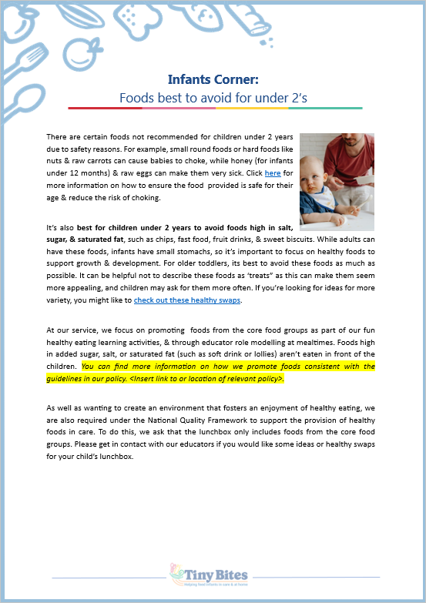 | The editable word version of the snippet can be found here:  https://www.goodforkids.nsw.gov.au/media/3015/snippet-8-foods-best-to-avoid-for-under-2s-lunchbox-services-word-doc.docx  Examples of how this version could be shared with families:  - Copy across to the body of emails or include as attachments  - Add to existing newsletters  - Printed copies for handouts, parent pockets or to display in the service  Feel free to edit the content in the document to align with your service’s preferences  and practices. When editing the word document, we recommend the snippet still includes:  - Why the practice is important  - How families may implement the practice  - How the service implements the practice  - Links to resources  Note, there is optional / modifiable content highlighted in yellow in the document. Please either:  - make any necessary edits to this content to suit your service’s needs and then remove the highlight  - remove the content highlighted in yellow if it’s not relevant  You may also like to add your own photos and logos to this version of the snippet.

Option 3 – Create Your Own
If you’re creating your own, we recommend the snippet still includes:
- Why the practice is important
- How families may implement the practice
- How the service implements the practice
- Links to resources

Heading | Content | Image/Picture | Logo
 | Feel free to edit the content below to suit your service’s practices and preferences. You may like to add in your strategies used at the service to support families to provide foods consistent with the guidelines (see optional content highlighted in yellow below). For the highlighted content, please either:  - make any necessary edits to this content to suit your service’s needs and then remove the highlight  - remove the content highlighted in yellow if it’s not relevant | Feel free to swap out for your own photo. | You may also like to add your own logo as well.
Infant’s Corner: Foods best to avoid for under 2’s | There are certain foods not recommended for children under 2 years due to safety reasons. For example, small round foods or hard foods like nuts & raw carrots can cause babies to choke, while honey (for infants under 12 months) & raw eggs can make them very sick. Click here for more information on how to ensure the food provided is safe for their age & reduce the risk of choking.  It’s also best for children under 2 years to avoid foods high in salt, sugar, & saturated fat, such as chips, fast food, fruit drinks, & sweet biscuits. While adults can have these foods, infants have small stomachs, so it’s important to focus on healthy foods to support growth & development. For older toddlers, its best to avoid these foods as much as possible. It can be helpful not to describe these foods as ‘treats” as this can make them seem more appealing, and children may ask for them more often. If you’re looking for ideas for more variety, you might like to check out these healthy swaps.  At our service, we focus on promoting foods from the core food groups as part of our fun healthy eating learning activities, & through educator role modelling at mealtimes. Foods high in added sugar, salt, or saturated fat (such as soft drink or lollies) aren’t eaten in front of the children. You can find more information on how we promote foods consistent with the guidelines in our policy. <Insert link to or location of relevant policy>.  As well as wanting to create an environment that fosters an enjoyment of healthy eating, we are also required under the National Quality Framework to support the provision of healthy foods in care. To do this, we ask that the lunchbox only includes foods from the core food groups. Please get in contact with our educators if you would like some ideas or healthy swaps for your child’s lunchbox. |  | 

