**Infants Corner:**

Foods best to avoid for under 2’s

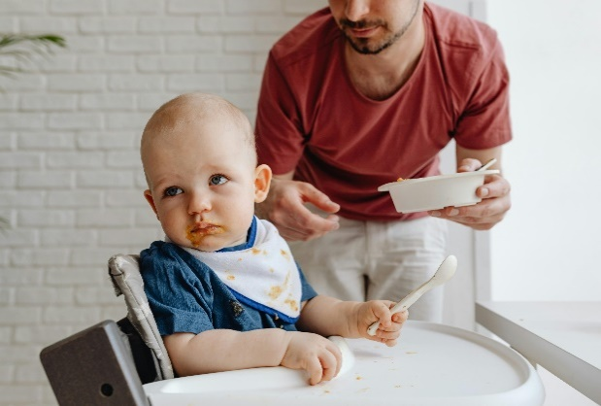There are certain foods not recommended for children under 2 years due to safety reasons. For example, small round foods or hard foods like nuts & raw carrots can cause babies to choke, while honey (for infants under 12 months) & raw eggs can make them very sick. Click [here](https://health-promotion.nnswlhd.health.nsw.gov.au/feeding-babies/foods-to-avoid/) for more information on how to ensure the food provided is safe for their age & reduce the risk of choking.

It’s also **best for children under 2 years to avoid foods high in salt, sugar, & saturated fat**, such as chips, fast food, fruit drinks, & sweet biscuits. While adults can have these foods, infants have small stomachs, so it’s important to focus on healthy foods to support growth & development. For older toddlers, its best to avoid these foods as much as possible. It can be helpful not to describe these foods as ‘treats” as this can make them seem more appealing, and children may ask for them more often. If you’re looking for ideas for more variety, you might like to [check out these healthy swaps](https://www.goodforkids.nsw.gov.au/media/2983/food-swaps-for-infants-toddlers.pdf).

At our service, we focus on promoting foods from the core food groups as part of our fun healthy eating learning activities, & through educator role modelling at mealtimes. Foods high in added sugar, salt, or saturated fat (such as soft drink or lollies) aren’t eaten in front of the children. *You can find more information on how we promote foods consistent with the guidelines in our policy. <Insert link to or location of relevant policy>.*

As well as wanting to create an environment that fosters an enjoyment of healthy eating, we are also required under the National Quality Framework to support the provision of healthy foods in care. To do this, we ask that the lunchbox only includes foods from the core food groups. Please get in contact with our educators if you would like some ideas or healthy swaps for your child’s lunchbox.