Tiny Bites Snippet: How do I tell if my child is hungry or full?

Choose the snippet option you would like to share with families at your service.
You may like to share the snippet in multiple formats!
Option 1
Formatted Snippet / PDF (this one isn’t modifiable) – click here.

Option 2
Word document (with modifiable text) – click here.

Option 3
Create Your Own (with modifiable text) click here.
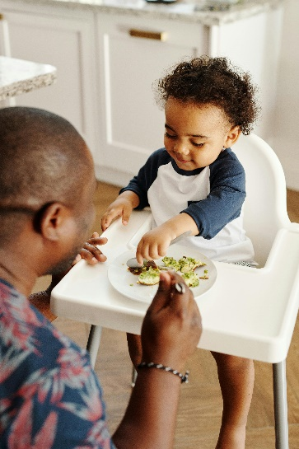

Contact your Tiny Bites Support Officer if you have any questions or require support in tailoring your snippets.

Option 1 – Formatted Snippet / PDF:

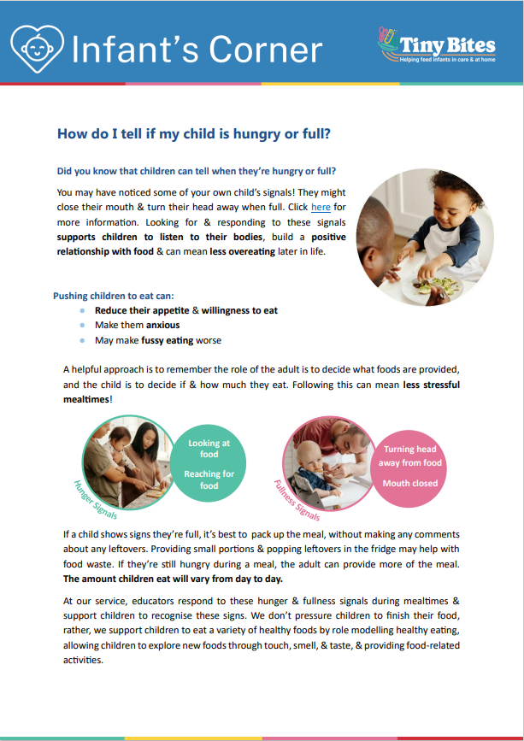 | The PDF version of the snippet can be found here:  https://www.goodforkids.nsw.gov.au/media/2970/snippet-4-responding-to-cues-not-pressuring-to-eat-pdf.pdf  Examples of how this version could be shared with families:  - Attach to emails  - Add to existing newsletters  - Printed copies for handouts, parent pockets or to display in the service  You can share this version with families as is without making any edits. This version contains additional visual elements compared to other versions but doesn’t contain the modifiable text which appears in the other formats.  Please note, because this version is in PDF format, the content is unable to be edited. If you would like to use this version but require edits to be made, please contact your Tiny Bites Support Officer at: hnelhd-pophealthgfkresearch@health.nsw.gov.au

Option 2 – Editable word document:

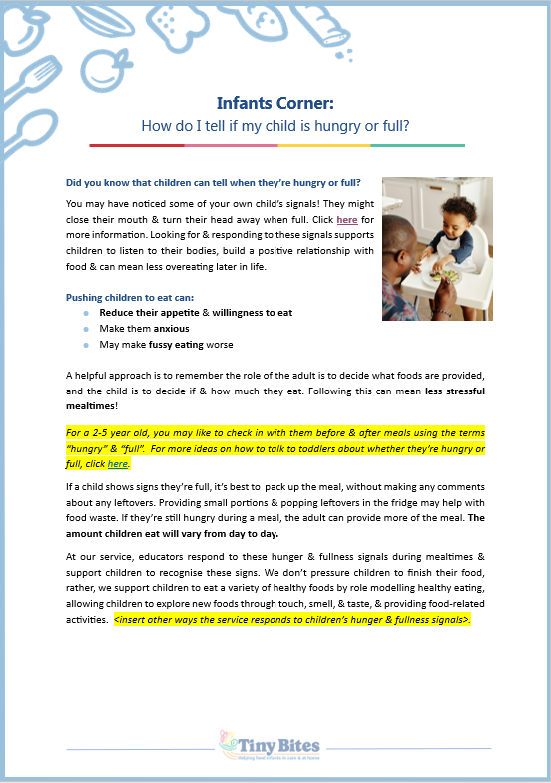 | The editable word version of the snippet can be found here:  https://www.goodforkids.nsw.gov.au/media/2971/snippet-4-responding-to-cues-not-pressuring-to-eat-word-doc.docx  Examples of how this version could be shared with families:  - Copy across to the body of emails or include as attachments  - Add to existing newsletters  - Printed copies for handouts, parent pockets or to display in the service  Feel free to edit the content in the document to align with your service’s preferences  and practices. When editing the word document, we recommend the snippet still includes:  - Why the practice is important  - How families may implement the practice  - How the service implements the practice  - Links to resources  Note, there is optional / modifiable content highlighted in yellow in the document. Please either:  - make any necessary edits to this content to suit your service’s needs and then remove the highlight  - remove the content highlighted in yellow if it’s not relevant  You may also like to add your own photos and logos to this version of the snippet.

Option 3 – Create Your Own
If you’re creating your own, we recommend the snippet still includes:
- Why the practice is important
- How families may implement the practice
- How the service implements the practice
- Links to resources

Heading | Content | Image/Picture | Logo
 | Feel free to edit the content below to suit your service’s practices and preferences. You may like to add in your strategies used at the service to support children to try new foods without pressure, or in responding to cues (see optional content highlighted in yellow below). For the highlighted content, please either:  - make any necessary edits to this content to suit your service’s needs and then remove the highlight  - remove the content highlighted in yellow if it’s not relevant | Feel free to swap out for your own photo. | You may also like to add your own logo as well.
Infants Corner: How do I tell if my child is hungry or full? | Did you know that children can tell when they’re hungry or full? You may have noticed some of your own child’s signals! They might close their mouth & turn their head away when full. Click here for more information. Looking for & responding to these signals supports children to listen to their bodies, build a positive relationship with food & can mean less overeating later in life.  Pushing children to eat can:  - Reduce their appetite & willingness to eat  - Make them anxious  - May make fussy eating worse  A helpful approach is to remember the role of the adult is to decide what foods are provided, and the child is to decide if & how much they eat. Following this can mean less stressful mealtimes!  For a 2-5 year old, you may like to check in with them before & after meals using the terms “hungry” & “full”. For more ideas on how to talk to toddlers about whether they’re hungry or full, click here.  If a child shows signs they’re full, it’s best to pack up the meal, without making any comments about any leftovers. Providing small portions & popping leftovers in the fridge may help with food waste. If they’re still hungry during a meal, the adult can provide more of the meal. The amount children eat will vary from day to day.  At our service, educators respond to these hunger & fullness signals during mealtimes & support children to recognise these signs. We don’t pressure children to finish their food, rather, we support children to eat a variety of healthy foods by role modelling healthy eating, allowing children to explore new foods through touch, smell, & taste, & providing food-related activities. <insert other ways the service responds to children’s hunger & fullness signals>. |  | 

