Tiny Bites Snippet: When’s the best time to move away from bottles?

Choose the snippet option you would like to share with families at your service.
You may like to share the snippet in multiple formats!
Option 1
Formatted Snippet / PDF (this one isn’t modifiable) – click here.

Option 2
Word document (with modifiable text) – click here.

Option 3
Create Your Own (with modifiable text) - click here.
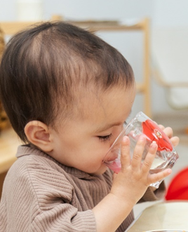

Contact your Tiny Bites Support Officer if you have any questions or require support in tailoring your snippets.

Option 1 – Formatted Snippet / PDF:

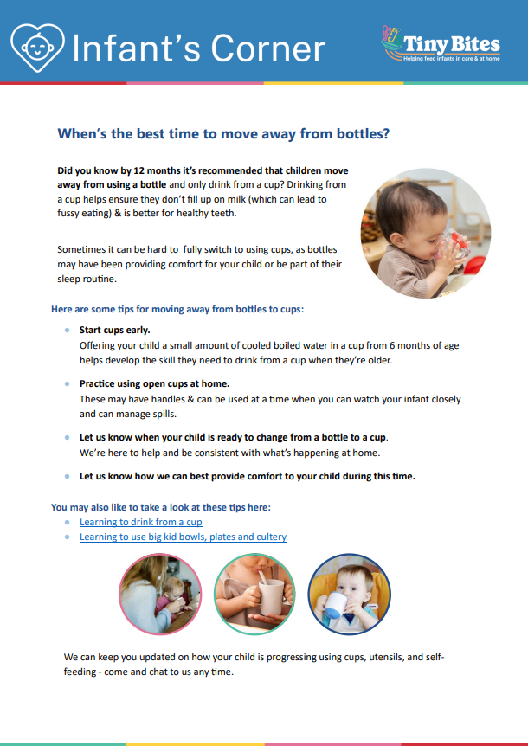 | The PDF version of the snippet can be found here:  https://www.goodforkids.nsw.gov.au/media/2967/snippet-5-learning-to-drink-from-a-cup-pdf.pdf  Examples of how this version could be shared with families:  - Attach to emails  - Add to existing newsletters  - Printed copies for handouts, parent pockets or to display in the service  You can share this version with families as is without making any edits. This version contains additional visual elements compared to other versions but doesn’t contain the modifiable text which appears in the other formats.  Please note, because this version is in PDF format, the content is unable to be edited. If you would like to use this version but require edits to be made, please contact your Tiny Bites Support Officer at: hnelhd-pophealthgfkresearch@health.nsw.gov.au

Option 2 – Editable word document:

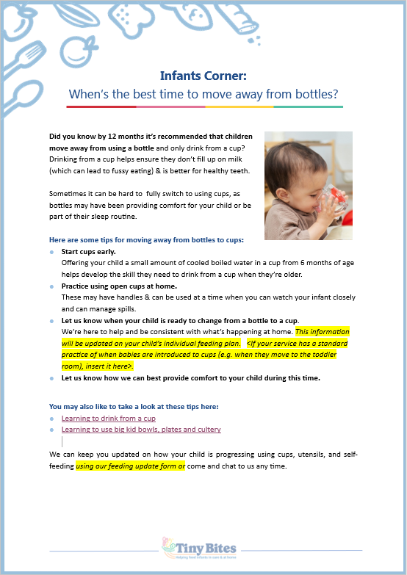 | The editable word version of the snippet can be found here:  https://www.goodforkids.nsw.gov.au/media/2968/snippet-5-learning-to-drink-from-a-cup-word-doc.docx  Examples of how this version could be shared with families:  - Copy across to the body of emails or include as attachments  - Add to existing newsletters  - Printed copies for handouts, parent pockets or to display in the service  Feel free to edit the content in the document to align with your service’s preferences  and practices. When editing the word document, we recommend the snippet still includes:  - Why the practice is important  - How families may implement the practice  - How the service implements the practice  - Links to resources  Note, there is optional / modifiable content highlighted in yellow in the document. Please either:  - make any necessary edits to this content to suit your service’s needs and then remove the highlight  - remove the content highlighted in yellow if it’s not relevant  You may also like to add your own photos and logos to this version of the snippet.

Option 3 – Create Your Own
If you’re creating your own, we recommend the snippet still includes:
- Why the practice is important
- How families may implement the practice
- How the service implements the practice
- Links to resources

Heading | Content | Image/Picture | Logo
 | Feel free to edit the content below to suit your service’s practices and preferences. You may like to add in your strategies used at the service to support families when their child is ready to change from a bottle to a cup (see optional content highlighted in yellow below). For the highlighted content, please either:  - make any necessary edits to this content to suit your service’s needs and then remove the highlight  - remove the content highlighted in yellow if it’s not relevant | Feel free to swap out for your own photo. | You may also like to add your own logo as well.
Infants Corner: When’s the best time to move away from bottles? | Did you know by 12 months it’s recommended that children move away from using a bottle and only drink from a cup?  Drinking from a cup helps ensure they don’t fill up on milk (which can lead to fussy eating) & is better for healthy teeth.  Sometimes it can be hard to fully switch to using cups, as bottles may have been providing comfort for your child or be part of their sleep routine.  Here are some tips for moving away from bottles to cups:  - Start cups early. Offering your child a small amount of cooled boiled water in a cup from 6 months of age helps develop the skill they need to drink from a cup when they’re older.  - Practice using open cups at home. These may have handles & can be used at a time when you can watch your infant closely and can manage spills.  - Let us know when your child is ready to change from a bottle to a cup. We’re here to help and be consistent with what’s happening at home. This information will be updated on your child’s individual feeding plan. <If your service has a standard practice of when babies are introduced to cups (e.g. when they move to the toddler room), insert it here>.  - Let us know how we can best provide comfort to your child during this time.  You may also like to rake a look at these tips here:  - Learning to drink from a cup  - Learning to use big kid bowls, plates and cultery  We can keep you updated on how your child is progressing using cups, utensils, and self-feeding using our feeding update form or come and chat to us any time. |  | 

