**Infants Corner:**

When’s the best time to move away from bottles?

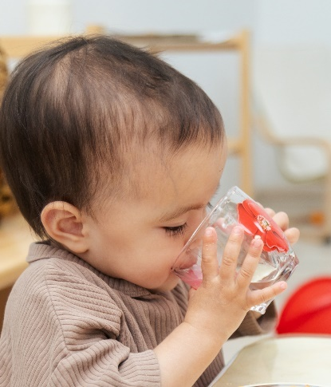**Did you know by 12 months it’s recommended that children move away from using a bottle** and only drink from a cup?

Drinking from a cup helps ensure they don’t fill up on milk (which can lead to fussy eating) & is better for healthy teeth.

Sometimes it can be hard to fully switch to using cups, as bottles may have been providing comfort for your child or be part of their sleep routine.

**Here are some tips for moving away from bottles to cups:**

* **Start cups early.**

Offering your child a small amount of cooled boiled water in a cup from 6 months of age helps develop the skill they need to drink from a cup when they’re older.

* **Practice using open cups at home.**

These may have handles & can be used at a time when you can watch your infant closely and can manage spills.

* **Let us know when your child is ready to change from a bottle to a cup**.

We’re here to help and be consistent with what’s happening at home. *This information will be updated on your child’s individual feeding plan.*   *<If your service has a standard practice of when babies are introduced to cups (e.g. when they move to the toddler room), insert it here>.*

* **Let us know how we can best provide comfort to your child** **during this time.**

**You may also like to take a look at these tips here:**

* + [Learning to drink from a cup](https://indd.adobe.com/view/30441ad8-7161-4694-b575-c63da3eb9834)
  + [Learning to use big kid bowls, plates and cultery](https://indd.adobe.com/view/70ec02f0-7db8-45ab-a326-a87fe780f6f3)

We can keep you updated on how your child is progressing using cups, utensils, and self-feeding *using our feeding update form or* come and chat to us any time.