Tiny Bites Snippet: Welcome to Tiny Bites!

Choose the snippet option you would like to share with families at your service.
You may like to share the snippet in multiple formats!
Option 1
Formatted Snippet / PDF (this one isn’t modifiable) – click here.

Option 2
Word document (with modifiable text) – click here.

Option 3
Create Your Own (with modifiable text) click here.
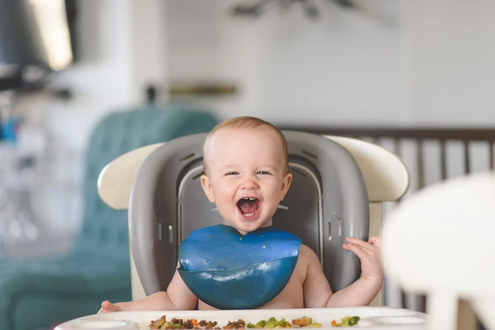

Contact your Tiny Bites Support Officer if you have any questions or require support in tailoring your snippets.

Option 1 – Formatted Snippet / PDF:

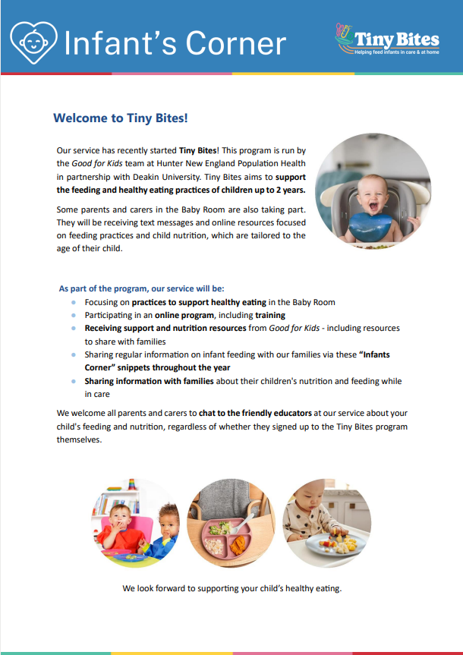 | The PDF version of the snippet can be found here:  https://www.goodforkids.nsw.gov.au/media/2899/snippet-1-introduction-to-tiny-bites-pdf.pdf  Examples of how this version could be shared with families:  - Attach to emails  - Add to existing newsletters  - Printed copies for handouts, parent pockets or to display in the service  You can share this version with families as is without making any edits. This version contains additional visual elements compared to other versions but doesn’t contain the modifiable text which appears in the other formats.  Please note, because this version is in PDF format, the content is unable to be edited. If you would like to use this version but require edits to be made, please contact your Tiny Bites Support Officer at: hnelhd-pophealthgfkresearch@health.nsw.gov.au

Option 2 – Editable word document:

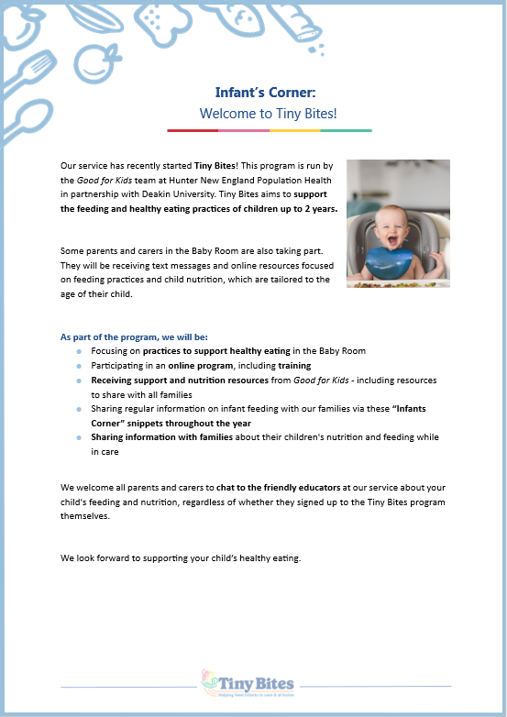 | The editable word version of the snippet can be found here:  https://www.goodforkids.nsw.gov.au/media/2898/snippet-1-introduction-to-tiny-bites-word-doc.docx  Examples of how this version could be shared with families:  - Copy across to the body of emails or include as attachments  - Add to existing newsletters  - Printed copies for handouts, parent pockets or to display in the service  Feel free to edit the content in the document to align with your service’s preferences  and practices. When editing the word document, we recommend the snippet still includes:  - What Tiny Bites is, noting that is a program run by Good for Kids in partnership with Deakin University  - That some parents & carers will be receiving text messages  - What the service will be doing as part of the program  You may also like to add your own photos and logos to this version of the snippet.

Option 3 – Create Your Own
If you’re creating your own, we recommend the snippet still includes:
- What Tiny Bites is, noting that is a program run by Good for Kids in partnership with Deakin University
- That some parents & carers will be receiving text messages
- What the service will be doing as part of the program

Heading | Content | Image/Picture | Logo
 | Feel free to edit the content below to suit your service’s practices and preferences. | Feel free to swap out for your own photo. | You may also like to add your own logo as well.
Infants Corner: Welcome to Tiny Bites! | Our service has recently started Tiny Bites! This program is run by the Good for Kids team at Hunter New England Population Health in partnership with Deakin University. Tiny Bites aims to support the feeding and healthy eating practices of children up to 2 years.  Some parents and carers in the Baby Room are also taking part. They will be receiving text messages and online resources focused on feeding practices and child nutrition, which are tailored to the age of their child.  As part of the program, we will be:  - Focusing on practices to support healthy eating in the Baby Room  - Participating in an online program, including training  - Receiving support and nutrition resources from Good for Kids - including resources to share with families  - Sharing regular information on infant feeding with our families via these “Infants Corner” snippets throughout the year  - Sharing information with families about their children's nutrition and feeding while in care  We welcome all parents and carers to chat to the friendly educators at our service about your child's feeding and nutrition, regardless of whether they signed up to the Tiny Bites program themselves.  We look forward to supporting your child’s healthy eating. |  | 

