**Munch & Move Best Practices for Promoting**

**Children’s Healthy Eating and Physical Activity**

**Key:**



Achieved

Working Towards – *Not yet achieved, but our service has steps in place to progress towards achievement*





Not a current focus – Our s*ervice has not achieved and is not a focus as yet*

**For each practice tick the appropriate symbol in the table to record your service progress:**

|  |  |  |  |  |  |  |  |  |  |  |  |  |  |  |  |  |  |
| --- | --- | --- | --- | --- | --- | --- | --- | --- | --- | --- | --- | --- | --- | --- | --- | --- | --- |
|  |  | |  |  |  | | --- | --- | --- | |  |  |  | |  |  |  | |  |  |  | |  |  |  | |  |  |  | |
|  |  |  |
|  |  |  |
|  |  |  |

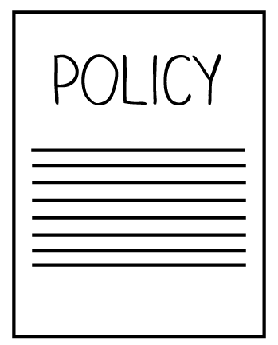

***Services that do not provide food:***

Our service observes children’s lunchboxes every day to ensure they are consistent with Australian Dietary Guidelines

Our service provides feedback to families if

lunchboxes are not consistent with

Australian Dietary Guidelines

**Our service has a written policy, procedure or guideline for:**

**Nutrition**

**Physical activity**

**Small screen recreation**

**Breastfeeding**

**\*refer to page 4 for the recommended elements to be included in each policy**

|  |  |  |
| --- | --- | --- |
|  |  |  |
|  |  |  |

|  |  |  |
| --- | --- | --- |
|  |  |  |

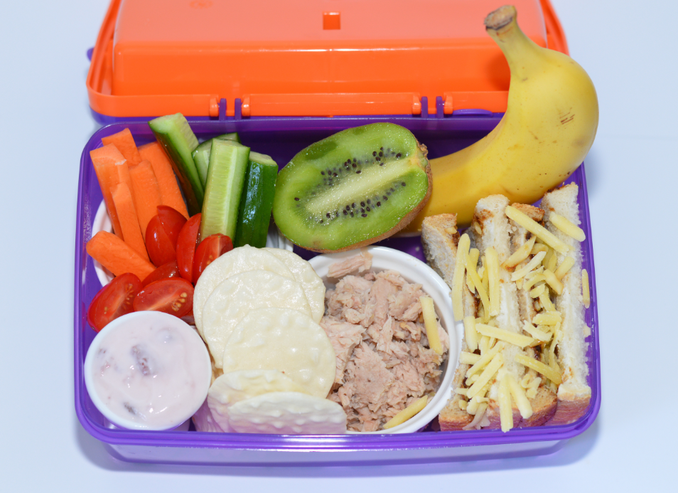

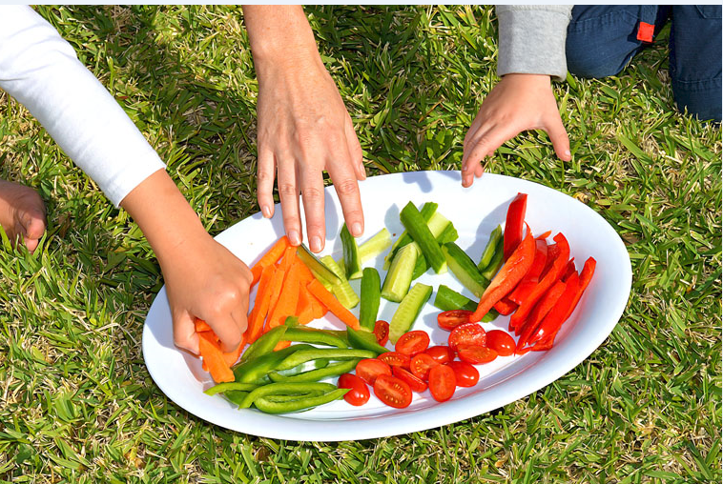

***Services that provide food:***

**A two week menu has been assessed by the Good for Kids team as meeting Caring for Children Guidelines**

**Our service cook has completed training in providing nutritious meals and snacks**

|  |  |  |
| --- | --- | --- |
|  |  |  |
|  |  |  |

|  |  |  |
| --- | --- | --- |
|  |  |  |

|  |  |  |
| --- | --- | --- |
|  |  |  |
|  |  |  |

***Services with children aged 0-12 months:***

**Our service displays the Australian Breastfeeding Association “Breastfeeding Welcome Here” or the Get Up & Grow “Breastfeeding-friendly zone” sticker**

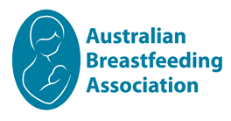

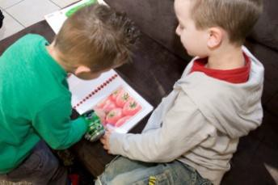

|  |  |  |
| --- | --- | --- |
|  |  |  |
|  |  |  |

Our service provides intentional learning experiences about healthy eating at least two times per week

Our service provides opportunities for physical activity for children ages 1-5 years for at least 30% of daily opening hours

Our service provides opportunities for outdoor and indoor active play

Our service has portable physical activity equipment to encourage active play

**Our educators role model healthy eating**

**and nutrition practices during meal times every day**

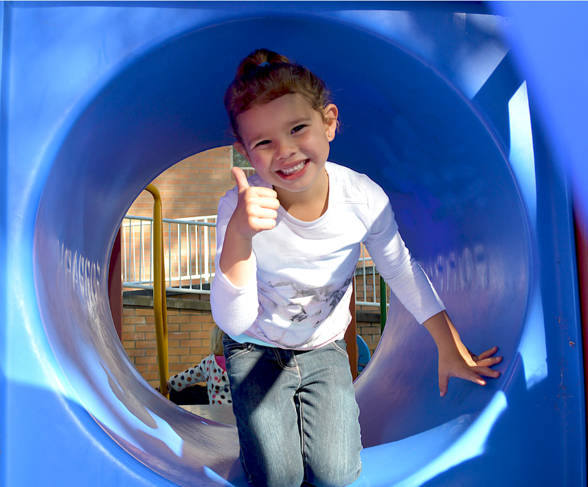

|  |  |  |
| --- | --- | --- |
|  |  |  |
|  |  |  |

|  |  |  |
| --- | --- | --- |
|  |  |  |

|  |  |  |
| --- | --- | --- |
|  |  |  |

|  |  |  |
| --- | --- | --- |
|  |  |  |
|  |  |  |

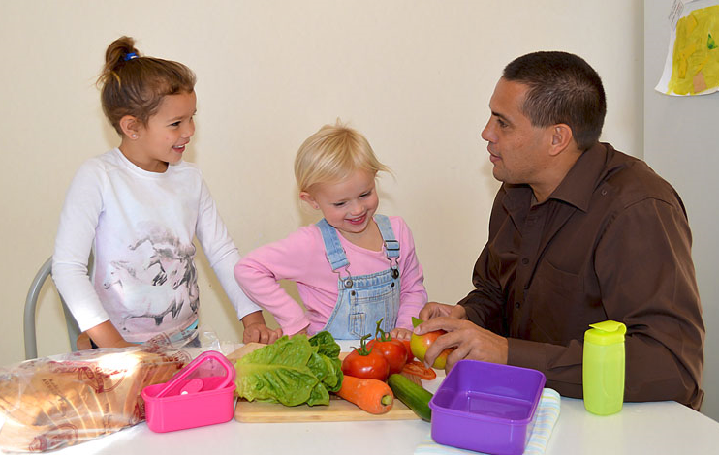

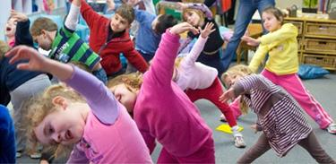

**Our service provides daily activities that intentionally teach and develop the fundamental movement skills for children ages 3-5 years**

|  |  |  |
| --- | --- | --- |
|  |  |  |
|  |  |  |

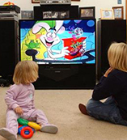

|  |  |  |
| --- | --- | --- |
|  |  |  |
|  |  |  |

|  |  |  |
| --- | --- | --- |
|  |  |  |

Our service use of small screen recreation is only for physical activity and/or educational purposes

Children aged under 2 years do not spend any time watching small screen devices

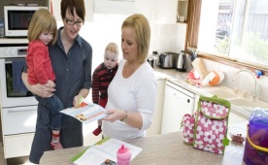

**Within the past 12 months our service has provided information to families on:**

**Healthy eating for children**

**Physical activity for children**

**Small screen recreation for children**

**Breastfeeding**

|  |  |  |
| --- | --- | --- |
|  |  |  |
|  |  |  |
|  |  |  |
|  |  |  |
|  |  |  |

Our service has at least 50% of educators that have attended professional development in nutrition and physical activity in the last 5 years

**Our service monitors and reports on healthy eating and physical activity achievements annually as part of continuous quality improvement processes**

|  |  |  |
| --- | --- | --- |
|  |  |  |
|  |  |  |

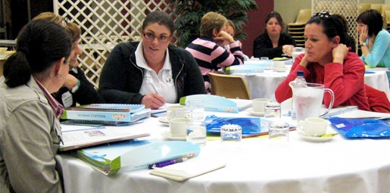

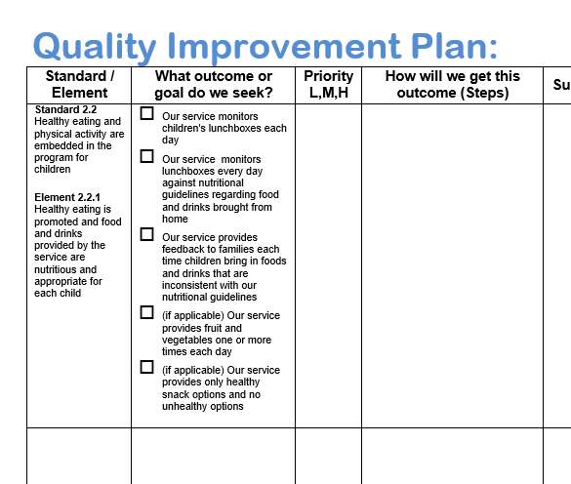

|  |  |  |
| --- | --- | --- |
|  |  |  |
|  |  |  |

**Recommended elements to be included in each policy, procedure or guideline:**

1. **Nutrition policy, procedure or guideline**

* Food provided by the service is consistent with the *Australian Dietary Guidelines* (services that provide food only)
* Strategies are in place to ensure that food provided by families in lunchboxes is consistent with the *Australian Dietary Guidelines* (services that do not provide food only)
* Strategies are in place to ensure food isn’t used as a reward or incentive for children
* Educators role model healthy food and drink choices

1. **Physical activity policy, procedure or guideline**

* Reference to the National *Physical Activity Recommendations for Children 0-5 Years*
* Physical activity is embedded in the daily program through spontaneous and intentionally planned active play that is both child initiated and educator led
* Educators actively role model to children appropriate physical activity behaviours

1. **Small screen recreation policy, procedure or guideline**
   * Reference to the National *Physical Activity Recommendations for Children 0-5 Years (Sedentary Behaviour Recommendations)*
   * Not using screen time as a reward or to manage challenging behaviours
   * Educators are encouraged to role model appropriate screen behaviours to the children
2. **Breastfeeding policy, procedure or guideline (services with children aged 0-12 months)**

* Families are informed that the service and educators support breastfeeding when the families first make contact with the service (or during orientation)
* Families are asked about breastfeeding at the time of enrolment
* Services develop a documented feeding plan for breastfed infants
* Services provide a supportive physical environment for mothers who want to breastfeed